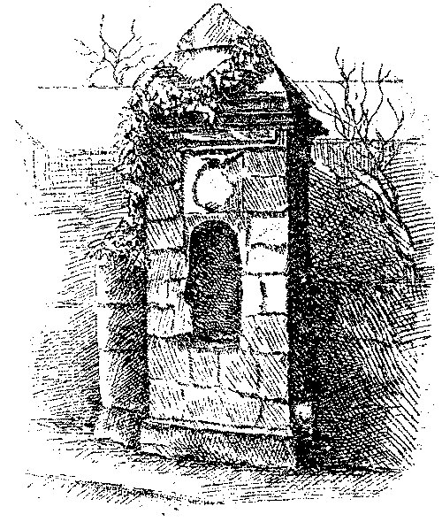
OSWESTRY
TOWN

WALL

GRŴP ARCHAEOLEGOL Y GORORAU

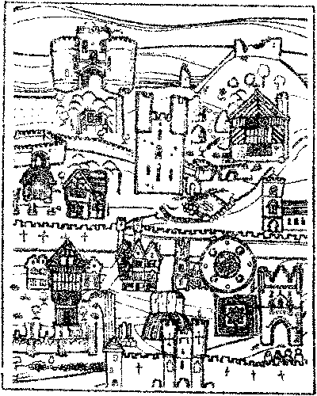

BORDER
COUNTIES ARCHAEOLOGICAL GROUP
[1980]
President Prof. G D B Jones, MA, D.Phil, FSA

This 2006 MS Word version attempts to preserve the original text and layout of the 1980 report. The content and order of each page remains the same but changes to the font and styles means that page numbers are altered and in some places the bottom line finishes early.
Several business names mentioned in the text no longer apply but have not been updated here. An online Internet version, now in preparation, will try and bring the names up to date.
Paul N Brown – February 2006
CONTENTS
FOREWORD 2
I. THE BUILDING OF THE WALL 5
THE CASTLE 5
GROWTH OF THE TOWN 5
THE MURAGE GRANTS 6
THE CONJECTURED LINE OF THE WALL 9
JOHN LELAND’S VISIT TO OSWESTRY 11
MISCELLANEOUS TOPOGRAPHICAL DETAIL 12
II. THE DESTRUCTION AND DISAPPEARANCE OF THE BOROUGH DEFENCES 15
INFILLING AND EXPANSION 16
GROWTH OF SUBURBS 17
DEVELOPMENTS ON THE BAILEY 18
ARCHAEOLOGICAL POTENTIAL OF THE CORE REGION 19
THE GREAT FIRES OF OSWESTRY 19
JOHN NORDEN’S SURVEY, 1602 21
THE STATE OF THE TOWN WALL 22
DECAY OF THE CASTLE 23
THE CIVIL WAR 23
DETERIORATION OF THE GATES 25
REMOVAL OF THE GATES 26
AN EXCAVATION STRATEGY 28
III. RECORDED SIGHTINGS OF THE WALL 31
IV. EXCAVATION REPORTS 38
CAE GLAS PARK I 41
CAE GLAS PARK II 43
WELSH WALLS 43
APPENDIX ‘A’. 45
The form of a Murage Grant 45
NOTES 47

FOREWORD
Between October 1979 and September 1980 members of the Border Counties Archaeological Group excavated a series of trial trenches in an attempt to establish the line of a section of the defensive wall that surrounded the medieval borough of Oswestry. Exploratory work has now ground to a temporary halt as the Group hopefully awaits the opportunity to investigate further potential sites as they are made available. It is, therefore, a suitable moment to take stock of what has so far been achieved in the search, and at the same time to make the Group’s activities known to a wider public.
A summary of progress - or lack of it - constitutes Part IV of this present compilation. However, the B.C.A.G. undertook the first excavation in 1979 at very short notice, and members quickly became aware that their knowledge of the history of Oswestry’s thirteenth century defences was woefully inadequate and perfunctory. Background research was not facilitated by the discovery that relatively little information on the town wall exists, and even that is scattered widely over a bewildering mass of primary and secondary sources. Consequently the B.C.A.G. Committee considered it desirable, as a necessary preliminary to further excavations, that, as far as possible, all existing information relating to Oswestry’s town wall and gates should be brought together in a form of ‘dossier’, and arranged, for ease of reference, into some systematic and chronological order. Such a narrative makes up the first three parts, and the bulk, of this report or ‘handbook’.
Part I outlines how Oswestry’s medieval castle, wall and gates came to be built. Part II traces the long, slow process of decay, and suggests reasons why such a substantial feature as a seven foot-thick wall, over a mile long, has disappeared without leaving any visible traces on the ground. Part III collates all known sightings of the wall since 1865. Surprisingly, there have been very few, and one is left in no doubt as to the enormity of the task the B.C.A.G. has set itself.
Finally, it has always been a matter of considerable frustration that the standard works on the history of Oswestry are neither graced by footnotes, nor possess a detailed bibliography, thus actively deterring the researcher from pursuing some aspect of his investigation in greater detail. Accordingly, a not inconsiderable effort has been made to rectify this omission in the preparation of this publication.
When not engaged on their own excavations, members of the B.C.A.G. help at other archaeological sites in Clwyd, south Cheshire and north Shropshire. During the winter the Group arranges monthly lectures at Oswestry and Wrexham, and between May and September organises a series of field trips under qualified leaders to places of historical and archaeological interest. The current programme and details of membership of the B.C.A.G. may be obtained from the Secretary?

Mrs. Carol James,
44 Vyrnwy Road,
OSWESTRY,
Shropshire, (Oswestry 5321 - office)

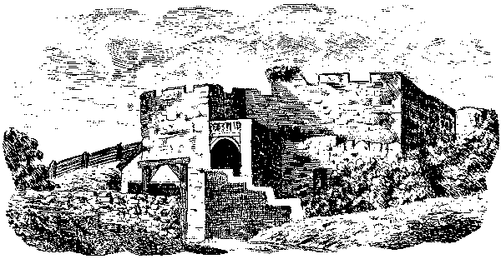

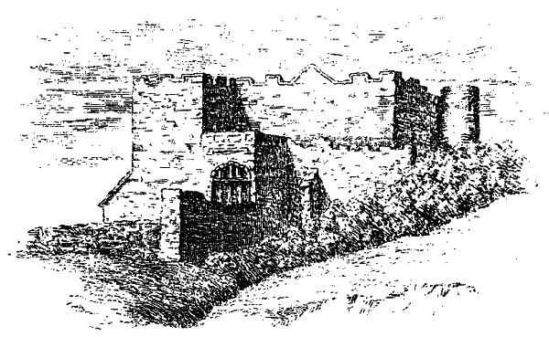

OSWESTRY CASTLE
These prints feature in early works on the history of the borough and clearly owe much to the artist’s imagination. They are, however, the only extant representation of the castle, taken "from an ancient Drawing belonging to an inhabitant of Dudleston".

THE SEARCH FOR OSWESTRY TOWN WALL
by DERRICK PRATT

I. THE BUILDING OF THE WALL

THE CASTLE
Town life in Oswestry began, in characteristic Marcher style, with the erection of a castle, the earliest of six motte and bailey structures that defined the westernmost limits of Norman penetration into northwest Shropshire (*l). Any of these castles was a potential nucleus for the development of a small urban settlement along the border with Wales.
Oswestry’s precarious, albeit strategic, position in the March of Wales, and its function in the thirteenth and fourteenth centuries as a border garrison town, ordained that its defensive capabilities should ultimately have been enhanced by the building of a wall, complete with what may be flatteringly termed ‘gatehouses’. It is a source of constant surprise to local historians that (a) almost two centuries elapsed before a wall was actually constructed, and (b), all traces of such a massive linear work have disappeared so completely. Its former course may only be accurately determined by piecemeal archaeological excavation or a rare exposure of footings during road improvements or building operations.
Domesday Book (1086) reveals that Renaud de Bailleul, sheriff of Shropshire and under-tenant of Roger de Montgomery, first earl of Shrewsbury, in addition to estates in Sussex, Warwickshire and Staffordshire, held over seventy manors in Shropshire. They included twelve of the eighteen manors in Mersete (later Oswestry) Hundred, which had its administrative centre at Meresberie (Maesbury). Within this latter manor, sometime after 1074, and on the orders of earl Roger, Renaud erected a castle, which, at the compilation of the Domesday survey, was evidently so new that it was referred to simply as Luvre (L’Oeuvre) or ‘the work’ (*2). For ease of construction Renaud utilised the smallest of the several mounds of glacial debris that screen Oswestry to the north, possibly that surmounted by the prominent tree that at one time grew on, or marked the boundary of, the estate of the Saxon farmer Oswald, after whom the town eventually was to be named (*3).

GROWTH OF THE TOWN
The early history of Oswestry is inextricably bound up with the annals of border warfare, recorded in both English and Welsh chronicles and in contemporary financial accounts (*4), and reflected in the fact that several widely disparate Shropshire manors, such as Pitchford, Alderton, and Withington, owed castle guard or knight service at Oswestry Castle (*5).
However, one must not lose sight of the fact that the Marcher lordship of Oswestry embraced both the hills and moorlands of Wales in the west and the Shropshire Plain extension in the east. The town of Oswestry itself is advantageously situated on the ‘fall line’,

the junction of two contrasting physical, economic, and cultural environments. Here the differences of race, language and geography were to blend and fuse in a manner excelled only at Wrexham among the urban communities of medieval Wales and the March. The small settlement that grew up in the shadow of Oswestry Castle very early took upon itself certain economic functions. It was for the improvement of its weekly market, and to exploit further the commercial possibilities of the town, that William FitzAlan, in 1189, granted Oswestry, or rather Blancmonasterium (*6), its first charter of incorporation, bestowing upon its inhabitants the customs and liberties of Shrewsbury (*7). The continued expansion of the borough was given further stimulus by the granting in 1228, despite opposition from the merchants of Montgomery and Shrewsbury, of the four-day St. Andrew’s Fair (30 November) (*8). In 1263 a second, more comprehensive seigneurial charter gave the burgesses, inter alia, the right to promulgate bye-laws for the profit and improvement of the borough (*9).
Medieval Oswestry’s economic sphere of influence was not restricted to the Perry basin and the valleys of the Tanat, Cynllaith and Cain, but extended beyond the Berwyns into Penllyn and Edeirnion (*10). Merchants from the Corwen, Llangar, and Bala areas followed the moorland roads and passes long familiar to Welsh marauding bands and armed expeditions from England. By 1272 the market tolls of Oswestry amounted to £20, rising to £27 in 1276; the tolls from the two fairs were farmed at £10 (*11). The borough was a tight agglomeration of houses and workshops that hugged the perimeter defences of the castle bailey and, indeed, increasingly encroached upon the outer courtyard.

THE MURAGE GRANTS
But even the most integrated town could not escape the periodic pillage and destruction of border warfare. Much of Oswestry was wasted by a vengeful King John in 1215 in the wake of Magna Carta, and again by Llewelyn ap Gruffydd of Gwynedd in 1230. That the town was attacked and sacked on several occasions before some thought was given to providing it with defences must be considered a characteristic feature of contemporary warfare and military strategy. The castle was still the key element in defence, and it, rather than the town, was the objective an attacking force sought to capture and control. The defence of the town was of only secondary importance, whereas occupation of the castle signified control of the lordship and its resources.
Murage grants to meet the cost of fortifying towns were first recorded in 1220, but it was not until 1257 that John FitzAlan II, lord of Oswestry 1244-67, petitioned for, and was granted on 28 December, a muragium or ‘wall tax’ for a period of five years to enable a wall to be built around the town (*12). Details are lacking about the construction of this wall, if indeed work actually started on it at all. If built this early wall could conceivably have been a simple bank and ditch strengthened by a timber palisade, as at Rhuddlan or Montgomery. A stone wall would have been only partially completed within the prescribed period, since a five-year murage grant, making the usual allowance for the misappropriation of funds by the murringers or collectors, would have produced insufficient funds to have walled about the whole of the existing town, particularly if it were intended

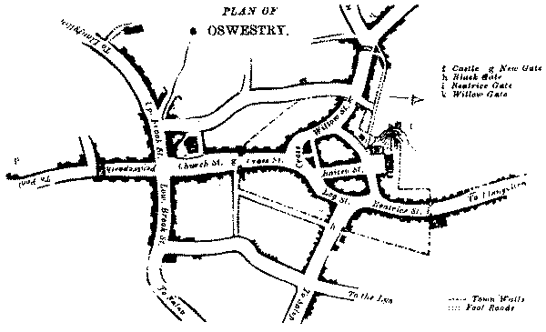

PRICE’S MAP OF OSWESTRY c.1815

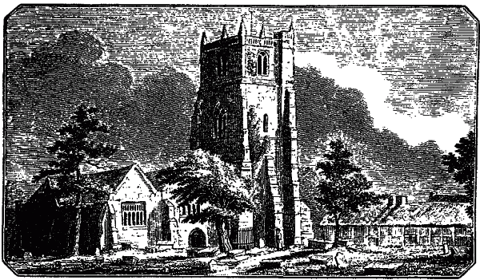

St. OSWALD’S CHURCH c.1812
The parish church of Oswestry was left outside the wall when built.
to include the parish church of St. Oswald within the fortifications. However, the character and extent of Oswestry’s subsequent expansion makes it most unlikely that these problems will be satisfactorily resolved, even by excavation on a larger scale than that carried out hitherto.
While it may have been a matter of pride amongst Marcher lords that their towns should have been walled, it was the strategic importance of Oswestry as a military base during the Welsh campaigns of Edward I that gave the necessary impetus either for the completion, or building de novo, of its defensive wall, possibly on a more circumscribed line than that originally envisaged, one that left the parish church outside the wall. War was declared against Llewelyn ap Gruffydd in November 1276, and in that same month some forty knights and seventy troopers were dispatched to Oswestry (*13). During the minority of Richard FitzAlan I (b. 1267), custody of the castle, town and lordship of Oswestry was in the hands of Bogo de Khoville, sheriff of Shropshire, Oswestry served as his headquarters from December 1276 to July 1277 and it was he, therefore, who was instrumental in securing, on 28 November 1277, a second, six-year, murage grant to the bailiffs and good men of Osolvestre for the purpose of adequately walling the entire circuit of the town (*14). The terminology hints possibly at a completely new start on the wall. Continued oversight of the work was maintained by Roger Springhouse, de Knoville’s successor as sheriff in 1278 or 1280. The wall, at least a mile in circumference, was to be ditched on the outside, which moat could be partly filled when needed by the several streams that traversed the town.
One can only speculate how far work on the town wall had proceeded before the fresh outbreak of hostilities on 21 March 1282. The following day, Palm Sunday, when its inhabitants least expected it, Oswestry was raided by Welshmen from Powys Fadog, Penllyn and Edeirnion. The castle was not taken, but the merchants and craftsmen of the town were plundered of goods to the tune of £470 15s. 0½d. (*15). In the ensuing campaign Roger Springhouse served under Roger Mortimer, the English commander in the middle March, as captain of forces at Oswestry. He maintained there, between May and August, a garrison of two heavy and two light troopers, three crossbows, and sixty foot. Their period of duty was extended for a further forty days from 9 August by the king’s special command (*16).
In the September and October the Welsh insurgents rapidly lost ground in the face of concerted advances by Edward I from Chester, and Roger Mortimer from Montgomery. But their resistance had not been altogether crushed, and on Monday, 14 September 1282, and again the following Sunday, Oswestry was once more the objective of audacious attacks by marauding bands of Welsh rebels, again drawn mainly from beyond the Berwyns, but on these two occasions also reinforced by malcontents from Dudleston, St. Martin’s, and Maelor Saesneg.
Many houses and shops were set on fire and damage to property in the town was conservatively estimated at £2,500 in silver (*17). Almost certainly the town wall, whether still only partly built or newly completed, would have sustained considerable damage by the simple, but effective expedient of toppling several courses of stone-work or

burning scaffolding and staging. It is against these events that one must view the letter patent, dated 24 February 1283, permitting the bailiffs of Oswestry to continue collecting murage in accordance with previous licences (*18), and another, dated 17 December 1283, which diversified the tolls payable, and increased the period of murage for a further twenty years (*19). Ostensibly this latter grant was for the repair of the town wall, but making good and completion is almost certainly meant. A translation of this grant is given as an Appendix to this report.

THE CONJECTURED LINE OF THE WALL
No further murage grant was made and it must be assumed that Oswestry’s town wall was completed by 1304. Remarkably, at the present time, no trace of the wall or its gateways remains above ground, hence the exploratory operations carried out by the B.C.A.G. in 1979-80. However, the position of the four gates may be determined with some exactitude, because, although linking stretches of wall had long vanished, they were retained, until their demolition in 1772 and 1782, as convenient points for the payment of tolls, which continued to be collected at these strategic points of entry into the borough until 1833-4.
Attempts to recover the exact line of the wall are hampered by the fact that, apart from that published by W. Price c.1815 in his History of Oswestry &c., there is not a single vintage map that purports to show the course of the wall (*21). This report will attempt to show that the greater part of the wall had been demolished by 1660, so that the chances of any significant remnant of the wall remaining exposed in 1815 must be considered very slender. It could also be argued that Price had an undoubted advantage over present-day researchers, that of writing some 166 years nearer actual events, at a time when oral tradition and/or human memory was perhaps stronger and more reliable. Unfortunately the scale and accuracy of his map is such as to render it virtually useless to any archaeologist seeking potential sites for exploratory trenches. Nevertheless, in the absence of any other cartographic evidence, Price’s map, with all its drawbacks, must serve to give an approximate indication of the wall’s conjectured alignment.
Price’s line has been modified by later researchers in the light of new theories held, but as yet all remain untested by excavation (*22). On the ground, even the most superficial survey of the presumed track of the wall has revealed that suitable areas for excavation are few and far between, and that the odds on actually cutting the line of the wall are immense. There would appear to be ample scope for a geophysical survey, coupled with the judicious use of a JCB, in any preliminary investigatory work!
From the New Gate pillar in Church Street the wall ran S.E. beneath the shops and derelict cottages on the left-hand side of English Walls (confirmed by a sighting in June 1973), swinging N.E. at the ‘Golden Tankard’ inn before running (possibly under the road) to ‘The Bear’ inn, where the Black Gate (Porth Ddu) straddle Salop Road or Leg Street. From thence the course of the wall is at its most problematical and hypothetical. It is generally assumed to have run a short distance parallel to the lane to Coney Green. At the rear of the Presbyterian

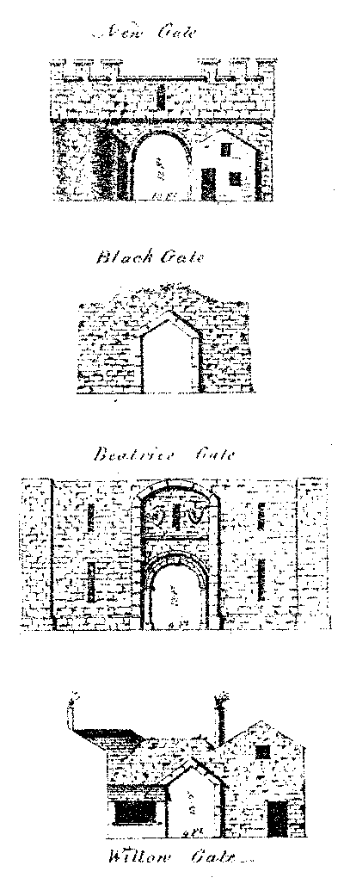
Ideal representations of Oswestry’s four gates as they would have appeared had restoration and other improvements taken place in preference to demolition in 1772 and 1782.

Chapel, Oswald Road, the wall presumably turned N.W., making for the ‘Plough’ inn at the top of King Street, where stood the Beatrice Gate. From here the wall continued up Plough Bank to the castle, effecting a junction with the latter’s defences and those of the bailey head. West of the castle motte or mound, the wall is thought to have run through the rear gardens of the houses on the left-hand side of Chapel Street to Castle Street, turning westwards to the Willow Gate, which stood at the junction of Willow Street, Welsh Walls and Castle Street. Eton the Willow Gate the wall ran along the left-hand side of Welsh Walls to somewhere near No. 27 where it turned sharply S.E. across Cae Glas Park, along one of several possible alignments, making for the Old Post Office (Agri-Electrics) yard and the New Gate.
Along the complete circuit of the town wall there have been less than a dozen confirmatory sightings of footings. In many places boundary and partition walls, and the walls of seventeenth and eighteenth century buildings, contain large amounts of worked and shaped stone, which, it is often asserted, may derive from derelict and dismantled walls. While it is tempting to accept this association one should not lose sight of the fact that there is a date discrepancy of some 150 years between the demolition of the wall and the building of those properties along its conjectural line, and that there are also many stone quarries in close proximity to the town.

JOHN LELAND’S VISIT TO OSWESTRY
One of the earliest, simplest, and yet most factual topographical descriptions of Oswestry is that afforded by the antiquarian John Leland, writing c.1539 (*23). Abstracting references relating specifically to the borough’s defences we read (translated Latin phrases underlined):
The cumpace of the towne withyn the walle is aboute a mile.
There be 4 gates, the New Gate (Portnewith) by south. The Blake Gate, alias Portdee, by south est toward Shrobsbyri.
The 3. Beteriche Gate, whence is the road of the same name which leads to the town, north est. toward Chester.
The 4. Williho Gate, alias Mountain Gate, because through this one travels to the nearby mountains almost four miles distant, north west toward the montaine of Penllin in Merionneth.
There be no towers in the waulles beside the gates. . The tounne is dikid about and brokettes ren ynto it. The Chirch of S. Oswalde is a very faire leddid chirch with a great torrid steple, but it standeth without the New Gate; so that no chiroh is there withyn the towne.
*******
Ther is a castelle sette on a mont be likelihod made by hand and dichid by south west betwist Beterice Gate and Williho Gate, to the wich the town waul cummith.
*******

There goith thorowg the town by the crosse a broke (*24) cumming from a place cullid Simons Welle, a bow shot without the waulle by north-west. This broke cummith in thorough the waulle betwixt Williho Gate and New Gate, and so renning thorough the towne, and goith oute under the Blak Gate
*******
Ther is a brook caullid Betterich, bycauae it rennith thorough a bridglet of tymber at Beterich Gate.
The 3. goyth under the stone bridges of Wulli Gate, New Gate and Blake Gate. Then go they all 3. with Crosse Broke a mile lower by south west in to Morda Ryver,
Leland’s description sheds light on how the moat could be watered, while references to the course of the Cross Brook, now culverted, may help recover the exact alignment of the wall in the featureless terrain of Cae Glas Park. The bare statement that Oswestry town wall did not possess a single tower throughout its not inconsiderable length would seem to call for some reassessment of its defensive role. Leland was writing when the greater part of the wall was yet intact, and one is inclined to accept his utterances in preference to an assertion made much later, in 1782, "that the town was formerly walled around and had several strong towers built on the wall thereof..." (*25).

MISCELLANEOUS TOPOGRAPHICAL DETAIL
Ancient wood engravings exist depicting the New Gate and Beatrice Gate in ruinous condition before demolition in 1782, while others purport to show all four gates in a rather more pristine condition (see page 7), as they would have appeared had the suggested restoration and alterations - notably the raising of the arches and the widening of the roadways - taken place as an alternative to demolition and removal. None of the gates would appear to have presented a formidable obstacle, being a simple passageway between two guard chambers, extending back inside the defences rather than forward to cover the bridge and adjacent sections of the wall.
The wall and gateways were built as an integrated whole. There is no evidence, apart from reading too much into their names, to support statements that New Gate and Beatrice Gate were built later (*26). The former, possibly remodelled in 1570, hence its name, also contained the town prison or lock-up and toll-collectors’ room. Regretfully, the various derivations of the name ‘Beatrice Gate’, which have enjoyed considerable currency, must be discounted on dating and place-name evidence (*27).
The building of Oswestry’s town wall was essentially a local effort, financed by monies raised locally within the lordship. Labour was recruited locally, local quarries supplied the stone, and supervision was entrusted to local masons. There was little sophistication in concept or execution of the work compared with Conway or Caernarvon, and one questions statements that the building of Oswestry’s wall was

carried out by Henry of Ellerton, officer of the royal works. No direct evidence exists for this, although there is considerable precedent. The accomplished nature of the design and lay-out of Denbigh Castle and Town Wall and the great baronial castles at Chirk and Holt show that the master of the king’s works was certainly involved in their initial planning and setting out. On the other hand, it may reasonably be argued that the relative crudity and weakness of the Oswestry defences ought not be attributed to the man, who, in 1304, was sub-magister to Master Walter of Hereford at Caernarvon, succeeding the latter there in 1309, and who, in 1318, in turn became ‘master and surveyor of the king’s works’ at all the castles in North Wales (*28).
Occasional references are made in contemporary records to a ‘Red Gate’ (rubra porta) and a ‘Cripple Gate’ (*29). The latter certainly did not form a prominent feature of Oswestry’s outer defences. The solitary reference locates the ‘Red Gate’ in the general area of the bailey head, more specifically, the length of a tenter’s frame from the bridge over the castle moat. It can only allude to the outer gate to the castle, possibly constructed of a brown or reddish sandstone, but more probably located in that higher part of the bailey known as le Redehull or ‘the red hill’ (*30). East of the castle motte, Bryn-y-castell, on the north side of Powys Place, stands on what used to be known as ‘Cripple Bank’, alleged site of an outer gate of the castle "at which the halt and blind were usually relieved". Sadly this romantic notion must be dismissed. ‘Cripple Gat’ is derived from O.E. crypel-geat = ‘a low opening in a fence or wall’ (lit. ‘a creeping gate’) sufficient to allow the ingress or egress of small animals such as sheep. More usually, as in Shrewsbury, it merely permitted the passage of a drain or sewer through the defences, in the case of Oswestry, from the castle ditch into the swamp at Cripple Gate and into the ‘Beatrice Brook’, the stream that drained Castle Fields (*31).

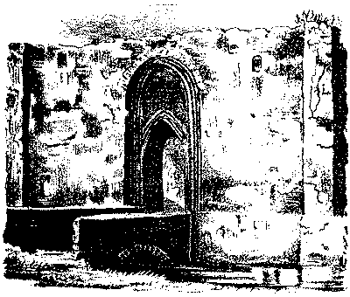
BEATRICE GATE

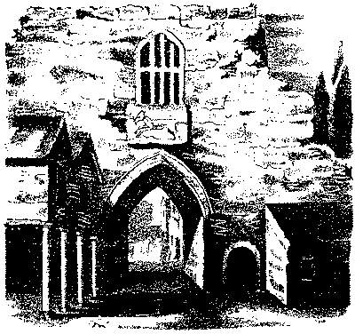
NEW GATE
Facsimiles of the Gates as they appeared when taken down in 1782

II. THE DESTRUCTION AND DISAPPEARANCE OF THE BOROUGH DEFENCES
While it possibly took some twenty-five years to build Oswestry’s town wall, assuming it was completed by 1304, the destruction of the borough’s outer defences took considerably longer. The blame for their disappearance must not be laid entirely at the door of the Parliamentarians under Basil Fielding, earl of Denbigh, and Col, Thomas Mytton, of Halston, in 1644. The obliteration of the inner defences, those of the bailey and castle, was more rapid, possibly being achieved by the mid-fifteenth century.
Several inter-related factors contributed to the slow, but steady process of destruction:
- The long period of relative peace, post 1407, which made the town wall more or less redundant.
- The consequent neglect of their obligations to maintain the wall by the burgesses of Oswestry, notably in the appropriation to other, more profitable uses, of monies ostensibly earmarked and collected for its repair.
- Such a situation was aggravated by the decline in the lord’s interest and authority in the internal affairs of the borough.
- The economic developments that made for the continued prosperity of the town not only stimulated in-filling within the walls, trespassing upon the bailey and its ditches, but also encouraged the expansion of the borough beyond the artificial restraining line of the wall.
- The piecemeal reduction and robbing of the wall to supply stone for building purposes, especially for fire-places, ovens, kilns etc. in the wake of the great fires of 1542, 1544 and 1567.
- The insertion of many private gateways and entrances along the line of the wall to give easier access to the town fields and property without the wall.
- The considerable damage inflicted during the Civil War, especially during the ‘Battle of Oswestry’ on 22 June 1644, followed by the slighting of the castle sometime after 1647 and the disappearance of the greater part of the wall between 1656 and 1660.
- Not in the least the vagaries of the weather upon an increasingly weakened and vulnerable wall.
In the late thirteenth and early fourteenth centuries the control of the earl of Arundel over his borough of Oswestry was still fairly tight, more so because, apart from a short period of royal custody or forfeiture, it had been in the hands of the powerful FitzAlan family for over two centuries (and was to remain in their possession until 1595). At no period did the several ecclesiastical estates within the borough develop into franchises strong enough to challenge seigneurial authority (*32). The newly erected wall was consequently maintained in a good state of repair.

The weakening of the lord’s authority was perhaps inevitable. No longer a single entity, focus of undivided interest, from 1334 onwards the lordship of Oswestry became a subsidiary unit in the rapidly expanding Arundel inheritance in the northern March, as first the lordship of Chirk, and then, in 1347, the lordship of Bromfield and Yale were added to the already extensive FitzAlan estates in Shropshire and the March (*33). The lord became an increasingly remote figure in the life of Oswestry as the boroughs of Chirk and Holt were actively, and preferentially, developed. Under Richard FitzAlan II particularly, Shrawardine Castle (Castle Philippa) became the main FitzAlan residence, Holt Castle the principal chancery, and Wrexham the busiest and wealthiest market town in Worth Wales and the border. Almost imperceptibly his rule in Oswestry became less restrictive, although, in the early stages, not too indulgent.
As the administration of the borough passed progressively into the hands of the burgesses, so the onslaught on the town wall and ditch gained momentum. Recognisable signs of self-government and nacent urban institutions are discernible in the charters of 1399 and 1407. Although many of the liberties contained therein are only immunities, exceptions, and limitations, including much valued non-intromittant clauses, the existence of a gild merchant and borough court served as the foundation upon which the fabric of greater urban privileges was to be built (*34). By 1582 the election of a common council and the existence of a Book of Constitutions, drawn up for the improved government of the town, would appear to indicate that the emaciated vestiges of seigniorial authority were then much atrophied (*35). The royal charters of 1616 and 1673, incorporating vital liberties and strong urban powers, formally mark the complete achievement of full corporate status by the borough (*36). Significantly, references to the wall and ditch fade from the records, only the crumbling gateways surviving for another century as a danger to pedestrians and a hazard to commercial traffic,

INFILLING AND EXPANSION
The street pattern in the centre of present-day Oswestry is basically that of the medieval borough, a crude horse-shoe shape imposed as the four main links with the outlying districts - Wyllya Strete, Midel Strete, Lege Strete and Bader Strete - skirted the castle mound and bailey area to converge in the forum mercatorium at the Cross, just below le blake ditch. . .
In 1276, before the wall was built, there were some forty-six burgage holdings in the borough. By 1301, in the rather fragile peace following the Welsh uprisings of 1282-4 and 1294-5, their number had increased to 127 and, in spite of the endemic plagues of the late fourteenth century, to 163 by 1393 (*37). The subdivision of burgage plots and the proliferation of smaller, irregular holdings - the shopae, placeae, tenementa and croftae of the surveys - points to the attraction of urban life in Oswestry. This was particularly noticeable in Beatrice Street, Leg Street and on the castle bailey, which areas early established themselves as zones favoured by small tradesmen and craftsmen, a social and occupational distinction even more sharply drawn in the surveys and tax assessments of two centuries later (*38).

With increasing pressure thus put on land within the perimeter wall, it is not surprising to discover that by 1393 substantial inroads had been made upon the original castle and bailey defences, and that not inconsiderable extra-mural extensions or suburbs were developing outside at least three of the four gates to the town (*39).

GROWTH OF SUBURBS
North of Oswestry an ancient trackway crossed Gwern y Bwrdeisiaid or Burgesses’ Moor, before forking to run to Whittington and Ellesmere, and via the Traean, that detached portion of Oswestry lordship, to Chirk and Wrexham. It was an important artery of commerce. Not surprisingly, by 1393, considerable ribbon development had taken place along it. Immediately outside the Beatrice Gate there were seventeen burgages, eleven crofts and a barn on the one side, and 10¾ burgages and croft on the other. This was always to be the largest suburb, with in Leland’s time "many barnes for corne and hay to the number of vii score several barnes" (*40). Such extra-mural developments did not here trespass upon the town ditch, which still carried the surface water from Cripple Gate and Castle Fields, but obviously the wall was to prove an irritant and a barrier to communication.
By contrast there was little suburban development outside the Black Gate, due possibly to the proximity of part of the lord’s demesne known as Park Issa or Lower Park, which had yet to be enclosed and subdivided. Even as late as 1795 there were less than a dozen cottages along the south side of the Shrewsbury road between English Walls and Croft Lane (*41). Encroachments noted in the records as being made upon le Blakediche or Black Ditch refer to the remnants of the bailey’s southern defences, bounded in part by Leg Street and Willow Street and the approximate course of which is still indicated by the narrow alley known as Clawdd Ddu.
Clearly the moat near the Cross was now dry and silted up, with its feeder stream, Leland’s ‘Cross Brook’, being permanently confined to its ditch or crudely culverted. Amongst the ‘new rents’ in the borough receiver’s account for 1362-3 (*42) is included 10s. 8d. from the erection of market stalls in the Black Ditch, and in 1393 four burgages, one placea, and four perticae (perches) of land had been carved out of this particular section of the inner moat. Such encroachments were invariably long, narrow strips, thirty feet wide and 22 - 33 yards in length. In 1398 one of these encroachments was held by Jankyn ap Gwyllym of Chirk, described as “one of the merchants of the principality of Chester”, but possibly also deputy-constable of Chirk Castle (*43). This may pinpoint a further factor behind infilling and the expansion of the borough - the admittance, as burgesses, of ‘foreigners’, especially Shrewsbury merchants and drapers.
The burgage plots that fronted the east side of Willow Street extended back towards the castle and onto the bailey. By 1393 they had obviously over-run the bailey’s western defences except for the occasional section of moat that rejoiced in such names as le foul-slogh (‘foul mire!), collecting not only storm water but also sewage from nearby houses. In that same year at least three crofts and gardens were extended even further back into the castle moat, such

aggrandizements being made by the sons of the current holders of the burgages on Willow Street. Several small lanes, about forty yards long separated blocks of properties and linked Willow Street with the bailey. Only one has survived, the present Arthur Street or Shut. The remainder had been enclosed and taken into adjacent holdings by 1602 (*44).
Outside the Willow Gate only a small outgrowth had accrued by 1393. This is perhaps not surprising along a road that rose sharply into the Welsh hills. Here Thomas de Haston, who already held within the walls four burgages, a croft and twenty-four acres, and the lord’s pinfold, had ventured to take over the site of the lord’s old tan yard, a croft, and ‘a certain ditch outside the gate’, which can only refer to the ditch or moat below the town wall. If for no other reason than it was at a slightly higher elevation, that part of the town moat from the Willow Gate to the castle was dry, unless it too was utilised to carry excess water from Castle Fields, and therefore more readily liable to encroachment.
By 1577 this suburb had expanded greatly and comprised some six houses, forty-two tenements, a cottage and sundry barns and stables, set amongst orchards, gardens, crofts and inclosures (*45).
In Middle Street (*46) and Church Street, described as a ‘royal way’ in the fourteenth century, resided Oswestry’s wealthier burgesses. Their multiple burgage holdings and more substantial houses afforded an almost rural aspect to the southern approaches to the town, contrasting markedly with the narrow winding streets and shuts of the town’s commercial core in Leg Street and on the bailey. Between New Gate and St. Oswald’s Church, in 1393, some twenty-four burgages fronted Church Street or encroached upon the town-field of Oceldemere (Sheldemer ) to form the suburb of Chirton (*47 ).

DEVELOPMENTS ON THE BAILEY
But it was in, and upon, the bailey that the greatest transformation was taking place. Leland could speak of Bayly Streate as the street of the forum maximum et mercatores, the hub of the market and the venue of merchants. It was inevitable that in the years before the wall was built, the bailey, originally a necessary adjunct to the castle, should also have accommodated and sheltered part of the infant urban community that nestled in the shadow of the castle. That in 1276 a distinction could still be drawn between infra ballium and extra ballium, suggests that at this time the original line of the bailey’s defences, moat and embankment or palisade, could still be traced, although rapidly disappearing. In that year fourteen burgesses held some 22½ burgage plots within the bailey (*49).
A contemporary account (1327-30) records payment’s made for the erecting of market stalls in the bailey (*50). By 1393 Willow Street burgages had encroached along the western perimeter of the bailey and the number of burgage holdings in the bailey itself had increased to 34¼, held by glovers, mercers, smiths, farriers, tax-collectors, clerks, wheelwrights, cordmakers, and ‘rackers’ or tenters. They were interspersed with shop-houses (one converted from a gaol), tenements, curtilages, crofts and the usual miscellaneous placeae or plots. The
evidence suggests that the general line of what was later Bailey Street was slowly being established and that infilling was proceeding apace, with disastrous consequences for its former defences. At the head of the bailey a Hall of Pleas or court-house had been erected, replacing an older building, converted into workshops, that stood in Leg Street. The castle ditch behind it, and in six other places, had been leased for gardens and building purposes. A long strip of land, hard against the castle moat, was reserved for tenter frames (*51).

ARCHAEOLOGICAL POTENTIAL OF THE CORE REGION
Thus by the end of the fourteenth century a picture begins to emerge of a thriving town literally bursting at the seams, outgrowing its defensive wall, but more particularly of an ancient bailey closely packed with buildings of every size, shape and function. But it would be over optimistic to assume that the simple process of archaeological excavation would allow the recovery of constructional details, the lay out of the medieval streets and alleys, or the exact line of the outer defences of both castle and bailey. Rather the converse would appear to hold true, for the archaeological potential of the medieval core region of Oswestry, bounded by the present Willow, Cross and Leg Streets, must generally be rated very low.
Before the B.C.A.G. embarked on its search for Oswestry town wall, there had been no properly conducted archaeological excavation in the town. As will be seen below, the several reports of sightings of portions of the town wall are vague, inexact, and all too often at second-hand. They add little to the scanty details of stratigraphy gained from one of the three trenches cut in Welsh Walls, outside the core area, in March 1980. Here the late medieval layers were reached some 50 cms. below the present surface level.
Medieval buildings varied in construction - some post-hole built, some framed, some with cob or clay walls, some with posts that stood on, rather than in, the ground - and at the best of times do not lend themselves to preservation. This is particularly so if it can be demonstrated that virtually the whole of Oswestry’s medieval core, and a large part of the suburbs, have been subject to several well-defined phases of redevelopment, some of them involuntary and unplanned. In combination such redevelopment is almost bound to have, had an adverse affect on the medieval stratigraphy and later occupational layers, apart perhaps from more substantial or deep seated features such as cess pits, larger post-holes, rubbish pits and cisterns.
With normal wear and tear medieval buildings were regularly replaced or modified - an average cycle or phase of some fifty years has been suggested - during which time the whole layout of the core area would undergo a complete, but natural, organic change. However, in practice, unforeseen factors frequently triggered off or stimulated more sudden and drastic change.

THE GREAT FIRES OF OSWESTRY
Reference has already been made to the destruction suffered by the inhabitants of Oswestry in 1215, 1230, and 1282, but even more pertinent to the present purpose of attempting to recover the line of the borough’s ancient defences, are the visitation of Owain Glyn Dwr’s

disorganised rabble on Wednesday, 22 September 1400, and the great fires that swept the town in 1542, 1544 and 1567.
The true extent of the damage inflicted on the borough in those heady, early days of Glyn Dwr’s rebellion, is not known, but the uprising was remembered with feeling for many years afterwards, indeed, as late as 1635! It was certainly used by the burgesses to give weight to protestations of poverty, and as an interminable excuse for the non-payment of rents, services and other dues. Such phrases as Oswestria pene tota conflagrata fuit occacione belli populi Wallensis pepper the court rolls of the borough throughout the reign of Henry IV (*52).
John Davies, writing in 1635 "from my poore house at Midlton, neare Oswestrie", was a compiler of a manuscript history of the borough and lordship of Oswestry for the earl of Arundel, and gives the original account of the great fires (*53):
"Si thence Owen Glendour’s rebellion I doe not finde that the towne was any more destroied by enemies or violent assault, but I finde that it was burnt by a great misfortune of fire, casually happeninge, thrice in Thirty yeares. Twoe longe streetes, w’th greate riches of that towne, were brent Anno domini 1542. And likewise, or worse in Anno 1544. And lastely Anno 1567, 200 houses (vz. seaven score w’thin the Wales, and three score w’thout, in the suburbs, beside cloath, corne, cattle etc.) were consumed by fire, w’ch fire began att 2 of the clock in the morninge and ended att foure, to the great marvelling of many, that soe greate a spoile in soe shorte a time should happen".
Fire was a constant hazard in any medieval town. Inadequately protected hearths, bake-ovens, brew-houses and fuel stacks, in close juxtaposition to combustible dwellings clustered closely together, made the occurrence and rapid spread of fires almost inevitable. The "twoe longe streetes" ravaged by fire in 1542 can only refer to Willow Street and the Leg Street/Beatrice Street axis. Devastation of the core area in 1567 must have been complete. After a prolonged dry spell, and fanned by a strong breeze, the fire burnt with an unusual intensity until there was nothing left for the flames to consume.
The financial loss and dislocation of commerce caused by these fires is not the prime concern of the archaeologist, but in a trading town such as Oswestry the loss of stock and tools was a crucial matter for the residents of the borough. It was only slight compensation that dwellings and business premises could be quickly rebuilt from local materials. Reconstruction went on apace, but not always along pre-existing lines. The opportunity was taken to sort out, and bring some order to, the haphazard jumble of buildings that once graced the bailey area. The regular lines of the late medieval burgage plots became blurred, or disappeared altogether, as fire damaged buildings were summarily levelled and cleared, to vanish, in the new order of things, under gardens, back-yards or

back-side lanes, where they may yet await recovery. Such, possibly, was the fate of the medieval building, the corner of which was exposed by B.C.A.G. excavators in Welsh Walls. Indeed, the ash and burnt debris that filled a stone-lined pit associated with a later phase of construction, may have derived from one of these sixteenth century conflagrations.
Undoubtedly the subsequent erection in Willow Street and Leg Street of more substantial Tudor dwellings, shop-houses and workshops, especially if they were cellared, drastically reduced the chances of present-day archaeologists recovering profiles, cross-sections and other traces of the bailey’s defences which otherwise would have survived, sealed by destruction and later occupation layers, even after infilling and levelling. Similarly, the iconoclastic impact of later, mainly nineteenth century, development in these two streets and the core area generally, will have had a further detrimental effect on archaeological stratigraphy, if not obliterating completely the medieval horizons.
Not surprisingly, therefore, with the above mentioned exception, no medieval building has survived in Oswestry. (This is not to say that, with a more detailed survey of existing buildings, one may not come to light). Regretfully, the remorseless machinery of urban renewal has spared all too few Tudor buildings, for example, ‘The Bell’, ‘The Fox’ and No. 29 Bailey Street. These number amongst the earliest buildings in Oswestry and are all sixteenth century interiors with nineteenth century or later frontages. The effect of the fire on the town wall is more difficult to assess. Timber work - gates, steps, rails, ladders, shoring would have been badly damaged. The demand for stone with which to construct more substantial hearths, chimneys, ovens and kilns, along with other fire precautions, would have triggered off a renewed onslaught upon the crumbling wall as a convenient, ready-made quarry of stone,

JOHN NORDEN’S SURVEY, 1602
In March 1602, Thomas Howard, baron de Walden and earl of Suffolk, lord of Oswestry, commissioned John Norden, senior, to compile a detailed survey of Oswestry borough and lordship as the first step towards resolving "divers doubts and ambiguities" concerning the ancient liberties and franchises then enjoyed by the burgesses of the town. While Norden was concerned primarily with tenurial obligations and clarifying the rights of the lord of the manor, he included in his report, almost as a stricture, valuable comments on the state of Oswestry Castle and the town wall some fifty years after the great fires (*54).
The castle was ruinous, being busily plundered for building materials by the local gentry, possibly with the active connivance of the lord’s officials in the borough. Even allowing for some exaggeration on the part of the surveyor, Norden’s criticism is such that one is constantly surprised at the military role that the town and castle was expected to play in the Civil War forty years later. The town of Oswestry was held for the king for two years prior to 1644, when it was taken by the Parliamentarians, but the subsequent slighting of

of the castle and destruction of the town wall was but the final stage in a process of gradual attrition initiated and connived at, over a long period of time, by the inhabitants of the town,
Norden was at pains to emphasise that the town ditch should revert into the lord’s hands in case it needed to be ‘re-edified’, that is, cleaned, deepened, and otherwise brought up to standard as a defensive obstacle. The surveyor was alarmed at the number of illegal encroachments made in both the castle and town ditches, mainly by burgesses such as Richard Blodwell and Richard Jone, ‘who had nothing to show’ in the way of leases or copy of court roll and paid no rent for the same. Between Beatrice Gate and the castle part of the town ditch now contained ‘the Buttes’ or archery targets.

THE STATE OF THE TOWN WALL
Fifteen burgesses, drawn from amongst the local gentry and trades-people, were empanelled as a jury of inquisition to supply Norden with all necessary information and the answers to twenty-six articles of enquiry. They were reticent or downright evasive in many of their answers and a punctilious surveyor adds his own comments. On the town wall we read:
"To the nynteth they saye that the Bayliffes and Muringer used to repayre the gates and walles of the said towne as farr forth as the portion of the toll to the intent allowed would extend, and we finde the gates and walles at this present farre out of reparacone, be whose default we knowe not. Also we find voluntarie breaches by reason of sundry doores made through the saide walles, one by Roger Edwards, gent., another by Richard Lloyd of Aston, the third by John ap John Gough, the fourth by Richard Marcroft, the fifth by Richard Jones and they find passage for water made through the same walles by Hugh ap Cadwallder, glover.
(Surveyor’s Note). Theis dores are a great weakening to the walls and notwistanding the presentment they continue as they did unless they be newly stoped up. It is also weakening and defaceing the towne. They say nothing touching the takeing away the stones of the inner part of the walles which I have remembered elsewhere”.
Norden makes it quite clear that a third part of the market tolls and all the profit from stallage or standings and the ‘tenseries’ (*55) at fairs, as collected by the murager and bailiffs, should have been set aside for the upkeep of the gates and wall, but as he bleakly notes: "... it apeareth by the folorne gates and the ruayned walls that they have bestoed little cost theis manie yeares but have converted the receytes of this third part of the tolle to other private uses ...." His further memoranda on the state of the wall and gates are even more revealing:
"TOWNE WALLES. It is specially to be regarded that the walles maye not be so abused as they are for the tenants doe pull down the principal great stones next theire own gardens and have soe weakened the walles that it is a wonder they stand

for as I went on top of the walles where in times past a man might have walked on the walles round without stop where nowe the walles are so undermyned and the Inner part scaled and the walles broken through at sundry places for doores which they will not reforme, though it much preiudice the walles, and being fallen your Lordship must allowe towards the repaire.
TOWNE GATES. The gates of the towne, 4 in number, are all verye ruinous and decayed all but the Churche gate where the Burgesses have made their election house. The rest the Burgesses should have repayred, but they suffer them to fall, and yet are allowed about £20 per annum towards it, which for as much they doe not repayre the gates and walles but are themselves the cause of the ruyne. It were not amisse they were deprived of the allowance, and that your Lordship would repaire the gates which would make verye habitable houses and yeeld a good yearley benefitt unto your Lordship".

DECAY OF THE CASTLE
The lord of the manor had long ceased to reside at Oswestry Castle. Indeed, the jury of inquisition could not recall its being garrisoned within living memory, although Norden did append a note to the effect that: "It apeareth by some recordes that the Lordes of the Manor of Oswestry did keepe a garison of men in the castle in the time of Welsh tumults which were in time past verie comon". The decaying pile was beyond both the proper custody of prisoners and the efforts of the solitary porter or door-keeper to prevent the piecemeal dismantling of the castle. As Norden notes:
"To the fourthe article they saye that greate waste hath bene committed and done upon the same castle as well in stones and lead as in iron and tymber. By whom when and by what warrant they know not, But suppose that such officers as had the overseeing of the said castle and keeping the kay of the doore ought to know the same. They saye that Richard Blodwalls servants with his teame carried divers dayes the stones by wayneloads awaye, and Harry ap Thomas tooke a shiet of lead out of the same castle.
(Surveyor’s Note). It is a pittiful thing to see soe prety a pile soe defaced, and nott fitt that the offenders should goe unpunished for they have taken down whole towres and taken and carried awaye the stone, tymber, yron and lead, throwne downe the forewalls, uncovered the mayne towres, taken of the lead, carried away some of the tymber, and the rest being uncovered rots"

THE CIVIL WAR
Not surprisingly, when tested by Parliamentary forces in the defences of Oswestry were found sadly lacking, and town and castle capitulated after only a token resistance. The previous year

Lord Arthur Capell, the Royalist commander in the area, had passed through Oswestry and had ordered the townspeople to extend and strengthen their defences (*56), an almost impossible task in view of the dilapidated state into which the wall and gates had been permitted to fall. There is no indication that outlying trenches and earthworks were constructed as, for example, at Chester and Nantwich.
The Oswestry garrison at the time of its surrender comprised ‘twenty gentlemen of Shropshire and Wales’ and some 200 officers and men, most of them ill-trained volunteers or conscripts from Wales. By noon on Saturday, 22 June 1644, Parliamentary forces under the earl of Denbigh had captured St. Oswald’s Church, a useful observation post and, with its massive tower, an outlying defensive bastion to the town. In the afternoon a short, but effective carronade cleared the defenders from the Church or New Gate, forcing them to take shelter in the castle. The town was entered and before night-fall the outer gate of the castle had been blown up-by a buttar, a primitive form of limpet mine. The following morning, before the castle entrance could be fired with pitch, the garrison capitulated, their lives being spared (*57).
Town wall and castle took a further battering when, on Saturday, 29 June, the Royalists under Col. Marrow, mounted a counter-attack. Heavy house-to-house street fighting raged for three days, the Royalists breaching the wall in several places, recapturing the church, but failing to take the castle. They were forced to withdraw to meet a relieving Parliamentary force marching from Knutsford under Sir Thomas Myddleton. Marrow was defeated on (?West) Felton Heath on Tuesday, 2 August, the remnants of his force fleeing in disarray to Shrewsbury. Oswestry was to remain in Parliamentary hands, and sometime between 1647 and 1651 the castle was slighted to render it even more unserviceable. A Parliamentary Survey compiled in March 1652 refers to:
"All that capitall messuage or manor house, commonly called Oswestrie Castle with its appurtenances.… abutting upon ye new Markette .house on ye east, and upon ye towne wall of Oswestrie on ye west …. The said castle is at present uninhabited, having lately been demolished, we have therefore taken a view of ye materialls thereof being stones only ..." (*58)
The same survey also mentions the town wall:
"... all that stone wall encompassing the towne of Oswestrie aforesaid, being about a mile in extent, and all those four gatehouses erected upon ye entrances into ye said towne, and all that ditch adjoining ye said wall. Note. The said gate houses may with small charge be made more commodious. But in case ye said wall and gate houses should be demolished (as is fit they should, most part thereof being much decayed), then ye materials thereof, being stone only, are worth upon ye place £100, and ye land on which they stand 100s. per year" (*59).
The greater part of the wall was demolished before 1660, but the gates did not suffer the same fate. Presumably from the point of view

of internal security there was far more to be gained by leaving them standing.
After the Restoration in 1660 the Crown made no effort to restore Oswestry Castle. As William Cathrall, the historian, lamented: "... but the Castle, so dilapidated and broken down, was permitted to lie in ruins ... and by degrees its shattered walls and fallen columns were carried away by nocturnal depredators until at length the vestiges of a fortress consisted of little more than the mound still left in our sight" (*60), In seeking a new charter (granted in 1673), the bailiffs and burgesses of Oswestry petitioned Charles II and stated they were "att theye time of ye late intestine warrs very greate sufferers for that having made ye towne a Garrison for your Majesty’s father it was taken by storme & ye suburbes all burnt and ye walls, castle and church demolished by ye late usurping powers..." (*61).

DETERIORATION OF THE GATES
These are the last references to the town wall as a complete entity. As already intimated, it must be assumed that the greater part of it was demolished shortly after 1652, and certainly before 1660. However, small sections either side of the gate-houses were left standing, not only to maintain the structural stability of already tottering edifices, but also more effectively to channel traders and traffic through the gateways to facilitate the collection of tolls. But it is clear that the earls of Powys, as lords of the manor, did little to maintain even these truncated remnants of the wall. The surviving records of the borough court leet and view of frankpledge are liberally sprinkled with presentments and fines for not repairing the gates and side-walling. The following extracts may shed light on their rapidly deteriorating condition, and go far to explain the final demolition of the gates in 1772 and 1782.

October 1736
(We present) "Also his Grace the Duke of Powys for not repaireing the Bettrice Gate, the same being dangerous by reason of takeing soe many stones of and leaving loose ones unsecured. Fine 10s. time till May being given."
"And wee doe alsoe present his Grace the lUke of Powys for not repaireing the Willow gate house which (is) ready to fall and very dangerous to passengers..Fine 20s. time given to repaire and secure, 6 weeks" (*62)"

13 October 1737
"Wee present Jonas Turner for not cleansing within the Bettridge Gate and for not repayreing the Wall soe far as concerns him. 6d., time 14 days."
"We also present Jonas Turner, Richard Owen, butcher, for not cleaneing within the Black Gate which more than ordinary dirty and wants repairation withall and what hee is obleiged to doe or cause to be done. 6d., and 14 days."
"We present the Lord Duke of Powys for demolishing the stones at the Bettridge Gate and for not secureing the loose stones there which .are dangerous to passengers &c, 40s., time 6 months."
"Wee doe alsoe present the Lord Duke of Powys for not repaireing the Willow Gate house and secureing it as it is very dangerous for all comers and goers through that Gate and ready to drop and the same ought to be repayred by him or his agents. 40s., time 6 months " (*63).

11 October 1738
"Wee alsoe present his Grace the Duke of Powys for not repayreing the Willow Gate house which is very dangerous to passengers goeing to and againe through the sayd gate and therefore a publique nuisance to all persons as well as the inhabitants of the neighbourhood".
"We further present his Grace the Duke of Powys for not secureing the loose stones of the Bettridge Gate and the Town Wall there which was demolished there and applyed otherwise for my said Lord Dukes use and his benefitt, the sayd stones being dangerous to passengers and therefore necessary to be secured for the safety of all people who have buysnes that way. 10s., time for a moneth to repair" (*64).
Because there was nothing left of the castle, the New Gate had for some time served as the common gaol of the borough. Its dilapidated state gave rise for concern, and in 1739 a- sub-committee was asked to ‘view’ the gaol and gate and to report back to the magistrates in Quarter Sessions. On 15 January it was ordered by the bench:
"Whereas for want of a proper and convenient place to confine prisoners within this town, divers evil disposed persons &c, have escaped due punishment &c., the Gate commonly called the New Gate be put in good & sufficient repair & rendered commodious & safe gaol for the confinement of all prisoners, and that a sum of 1½d, in the £ be assessed and levied on all inhabitants for the purpose" (*65).
In March 1752 one of the gate houses, unspecified, actually fell down. Watkin suggests that it was the New Gate, but it was more probably the Willow Gate, already noted as being ready to drop in 1737, and which ceases after this date to be mentioned in contemporary documents. At the Easter Sessions the following account was passed for payment (*66):
April 10 Thos. Jones for removing the rubbish of the gate that fell down at Oswestry, taking down the remaining part of the roof that was standing and taking care of the timber and stone £1 ?8s. 7d.

REMOVAL OF THE GATES
Apart from their generally dangerous, derelict state, the main problem of having medieval gateways straddling the four points of entry into a rapidly-expanding eighteenth century market town was the increasing inability of traffic to negotiate the openings. The approach roads to the town were repaired by the simple expedient of adding yet

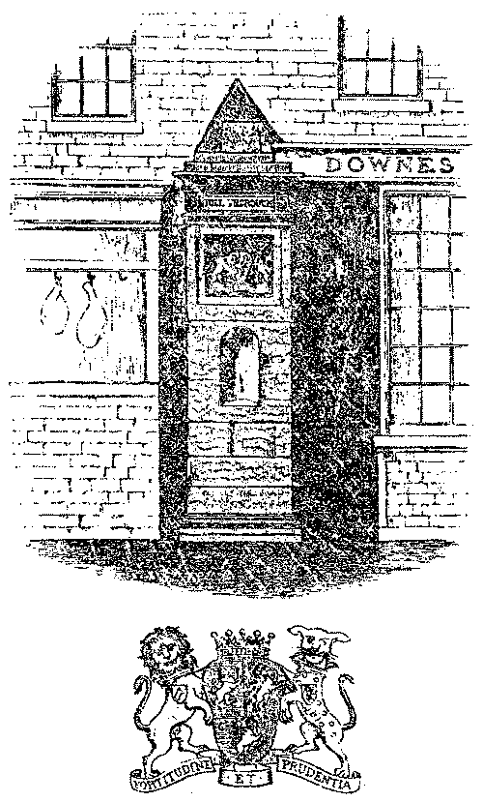
Pillar in Church Street, Oswestry. Erected in 1782 on the site of the New Gate. Arms of the earl of Powys, lord of the manor.
another layer of sand and metalling to the existing road surface. The gateways gradually became lower in the arch, often necessitating the partial unloading of laden carts as they made for the Bailey Head and Horsemarket. In 1767 the earl of Powys, yet again, was presented "for not repaireing the Black Gate, or taking it down, or raising it higher, being too low for carriages", and similarly, "for not raising the arch of the New Gate higher, it being too low for carriages and dangerous". If nothing was done within a month, the lord of the manor was to be fined £2 2s. in each case (*67).
Of course, nothing was done. The lord of the manor was not easily moved or intimidated’. However, in 1771 fifteen prominent gentlemen of the town and neighbourhood waited upon the earl of Powys with view "to permitting the Gates of the Town (which are all at present in a ruinous condition) to be taken down and the Materials apply’d in the erecting of necessary prisons, in another place, an Alteration that would prove not only very Ornamental to the town but very convenient for all sorts of Carriages ..." (*68).
Negotiations were to drag on for a number of years, although in November 1771 permission was given to demolish the Black Gate. This was in connection with a larger scheme then being carried out by the Turnpike Commissioners, that of widening and straightening the Shrewsbury road between the Black Gate and Carreg Llwyd. It was not until February 1781 that agreement was finally reached for the removal of the remaining gates and the erection, on site at two of them, of commemorative stone pillars carrying the arms of the earl of Powys and the words ‘TOLL THROUGH’. Such pillars were set up at the New Gate and Beatrice Gate. A single New Gate pillar still stands in Church Street between the premises of Messrs. John Redford and R.W. Gillham. Both Beatrice Gate pillars survived, although very much weathered. When the road up Plough Bank was constructed in 1881 the pillars were moved to the Castle Bank, where they now flank the entrance steps to the landscaped walks of the former castle motte (*69).

AN EXCAVATION STRATEGY
Thus vanished, almost exactly two centuries ago, the last vestiges of Oswestry’s medieval defences. As already noted, most of the wall had disappeared some 120 years before the gate, sufficiently a length of time for its exact line to be lost, and long before accurate, large-scale estate and tithe maps, which might have shown its position, became commonplace. Nothing remains on the surface, and buildings - shops, houses, tanneries, breweries, ironworks, warehouses etc, - which overlie the conjectured line of the wall, give no indication, either in their alignment or curtilage boundaries, of being in any way influenced by the physical presence of a wall.
For example, Nos. 25 and 27 Church Street were the last properties in medieval Middle Street, located hard up against, and parallel to, the interior face of the town wall. In size, shape and extent they conform to the ancient burgage plots. On the other hand Nos. 29 and 31 overlie the wall and ditch. They are shallow-fronted properties and were obviously erected when New Gate and the wall no longer offered obstacles to expansion. To their rear, in English Walls, Nos. 1 to 7 and the ‘Golden Tankard’ inn represent the development of the back-sides of properties fronting Church Street, opened out after the wall had been demolished. The several cottages, Nos. 5, 6, and 7 lying empty and derelict, the others converted to commercial uses, straddle diagonally the known line of the wall, exposed during building operations in 1973.
At a preliminary meeting on 7 December 1977 an overall excavation strategy was evolved. Four areas were considered as having potential as far as the likelihood of throwing up traces of the wall was concerned:

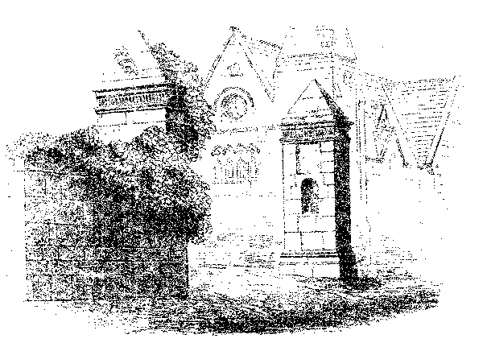
Pillars in situ on the site of Beatrice Gate. Note the fragment of town wall attached to pillar on west side of street. Erected in 1782, they were moved to their present position on Castle Bank in 1881.

1. In the back-sides of houses in Willow Street abutting on to Welsh Walls. Some have steps up to a raised section of garden, which, it was believed, might cover the foundations of the town wall. With hindsight, this proved to be an erroneous deduction. Excavation in March 1980, while not exposing the wall, did reveal the remains of a medieval building and an enigmatic ‘cobbled way’ (see Part IV of this report).
2. At the rear of the Old Post Office (Agri-Electrics) in Church Street. Here, not far from the New Gate pillar, and assuming the continuation of the line of the wall as exposed in English Walls in 1973, the town wall crossed the medieval Middle Street. There are several derelict buildings and pieces of waste land that could advantageously, be explored without much dislocation or inconvenience to owners. Some mechanical assistance would be needed to break through surface layers of rubble. The location of the wall here would be of inestimable value in helping to pin-point its course across Cae Glas Park.

3. In Coney Green, where again there is much waste land available for exploratory work. But it is in this complex of former warehouses and industrial buildings that the line of the north-eastern perimeter of the wall is at its most conjectural and much time and effort could be wasted. Given the opportunity, that section of wall immediately adjacent to, and north of, the Black Gate should be recoverable without too much difficulty. Further from the gate matters become more complicated, because somewhere the wall presumably makes a sharp angled turn to run on to Beatrice Gate through an area now completely built over and unrelieved by open spaces. The importance of being able to search in Coney Green - to establish two divergent lines of the wall - cannot be gainsaid, but on viewing the terrain it is clear that optimum results will only be obtained by ‘JCB archaeology’ as brought to a fine art in the city of Chester!
4. In Cae Glas Park, the only relatively undeveloped, open space along the supposed line of the wall. Here a 200 metre section of the wall awaits recovery. Over two centuries the park has obviously been landscaped to mask the wall’s foundations and to give the flat, featureless aspect of today. The formal lawns and gardens of the long demolished Cae Glas mansion were established between 1707 and 1791, and no doubt the last vestiges of the town wall had disappeared from sight and human ken by the latter date. Stables, conservatories, kitchen gardens and shrubberies, were tucked away out of sight of the house along the northern edge of the property, possibly atop one of the several suggested lines of the wall. Further landscaping, with material and fill from elsewhere, has taken place since the grounds became a public park. The first three trenches in the present series of exploratory ‘digs’ were sited in the park (see Part IV of this report) but proved inconclusive. It may be that some reassessment of the conjectured line will have to be made, particularly in the light of topographical writings. The possibility of carrying out a geo-physical survey should also be investigated.
5. Beneath the car-park at the junction of Willow Street and Castle Street. It is in this area that four of the reported sightings of the wall (see Part III of this report) have been made. The line of the wall immediately east of the Willow Gate runs up the centre of Castle Street and is exposed fleetingly during roadworks. Somewhere the wall turned south-east to run towards the castle. The buildings that formerly stood on the car-park site - Nos. 74-78(80) Willow Street, Nos. 51-77 Castle Street, and Nos. 2-4 Chapel Street, represent, in whole or in part, the development at the rear of at least two burgage plots after the wall was demolished. If the wall followed the line of Chapel Street to the castle, the car-park would prove a negative area; if it turned short of Chapel Street the new alignment underlies the car-park. However, the car-park has been given some semblance of semi-permanence by a tarmacadam surface, so that attention may be more profitably shifted to the neglected gardens and waste areas backing properties on the east side of Willow Street and the south side of Chapel Street.

III. RECORDED SIGHTINGS OF THE WALL

In that there are no visible remains of Oswestry’s town wall and gates, the archaeologist, in the first instance, must rely heavily on the evidence afforded by the casual sighting of the foundations to recover, however approximately, the former course of the wall. However, since 1865 only twelve recorded discoveries have been made of some residual fragment of the town’s medieval defences. These have been plotted (figures corresponding to numbered paragraphs below) on the composite map on page 28. The map also shows the conjectural, and frequently divergent, lines of the wall as worked out by various ‘authorities’ (*70) over the years. It illustrates well the size of the problem facing the B.C.A.G. in their current search for the wall! Almost certainly there have been many more sightings, but they have failed to excite the interest of the local populace and, coupled with ignorance as to the nature of the finds, they have gone unreported. Unfortunately, most of the sightings have occurred in areas where the line of the wall is more or less well substantiated; none have been reported from the large negative areas such as Coney Green, where our knowledge of the route followed by the wall is skimpiest or most contradictory.
Reported sightings are referred to either in I. Watkin, Oswestry &c, or Bygones, relating to Wales and the Border Counties. Frustratingly, they are second or third hand, unaccompanied by maps or diagrams, and lack the precision and detail which would allow the line of the wall to be pinpointed with greater accuracy. Brief, verbatim details of the sightings are as follows:
- "… and in l865, while excavating for the sewage drain, near the post office here, the workmen came across some steps at a depth of ten feet below street level, and at a depth of fourteen feet to some mud that probably formed the bed of the old moat .." (*71). In all probability this was the footings of the New Gate.
- “… and afterwards when some digging was being carried out in front of Mr. Bradley’s premises a block of solid masonry was exposed to view, and which it is believed formed part of the foundation of New Gate" (*72). Bradley’s was No. 26 Church Street, formerly, with No. 28, the ‘Cross Street Vaults’ and later the ‘Wrexham Hotel’. Now the premises of Derwas Bros., ironmongers (*73).
- The site of the Cambrian Service Garage at the junction of King Street and Beatrice Street was formerly occupied by a Wesleyan, later Methodist, church. Work on this building started in May 1870 and was completed in September 1871. "The excavation (? of the basement rooms) proved expensive, for it was found that the south wall ran in the course of the old town moat, making it necessary to go to the depth of twenty-eight feet below the ground floor line to reach a firm foundation .." (*74). A pity the wording here is ambiguous. Did the south wall of the church cut the moat or ditch at an angle as it ran from a point somewhere in Richard Street? Or did the wall run parallel to the moat,

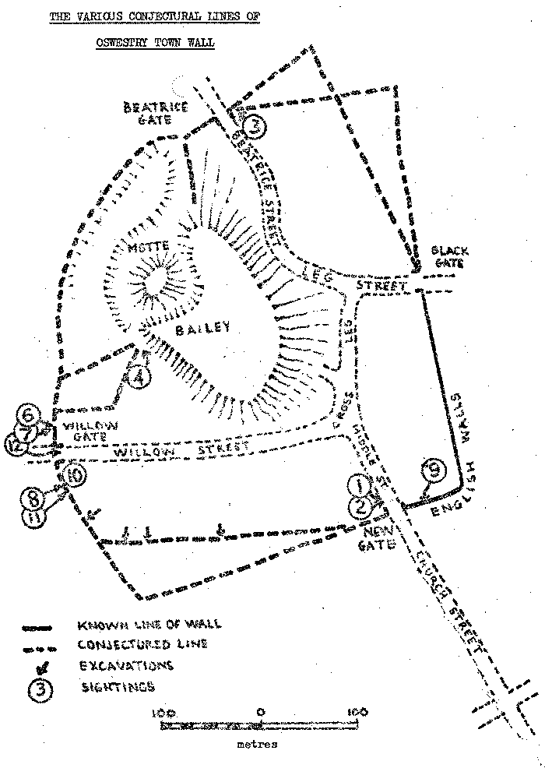
in which case the line of the ditch, and therefore the wall, possibly coincides with King Street?
- Christ Church, the United Reformed church in Arthur Street, immediately adjacent to the Castle Bank, was built on the site of the old lock-up, erected in 1826 and demolished in 1871. "The old lock-up was quickly demolished, and whilst excavations were being made, some stone work - presumably a portion of the town wall - was discovered by workmen ..." (*75). Again, a more explicit description could have shed light on the junction the wall made with the castle defences, and whether the wall ran off down Chapel Street or along some of the property boundaries to the rear of Willow Street.
- “The Oswestry Castle Bank Excavations. During the past week the excavations on the Castle Bank have revealed a perfect angle of what is conjectured to have been one of the rooms of the old castle. The committee have suggested that local antiquaries should inspect the place before it is again filled in. The work is being rapidly proceeded with” (*76). This discovery was made during landscaping activities prior to the handing over of Castle Bank (the former motte) to the townspeople of Oswestry to mark Queen Victoria’s Diamond Jubilee.
- "No. 80 Willow Street. Two cottages formerly stood upon the site of this ... About 1907 the property was acquired by the late Councillor Joseph Vaughan, and whilst preparing the foundations of the present building the excavators came across a portion of the old town walls" (*77). In present day terms, No. 80 would have stood on the white line down the middle of Castle Street ! It became part of a larger building, No. 78, itself demolished for road widening (see map on page 35). Nos. 72 - 76 Willow Street, along with Nos. 2-8 Chapel Street and Nos. 51 - 77 Castle Street have been replaced by a ‘temporary’ car park. This particular exposure would be immediately north of, possibly adjacent to, the fragment of wall exposed at the same road junction in November 1980 (see No.12 below).
- "THE WALLS OF OSWESTRY. An Interesting Discovery. Some building operations-at the junction of Willow Street and Castle Street, Oswestry, have resulted in the discovery of a portion of the wall which, at one time, surrounded the town. A block of buildings at this point is being rebuilt by order of Mr. Joseph Vaughan, who recently acquired the property, and it was during the pulling down of the old to make way for the new that men in the employ of Mr. Samuel, builder, discovered portions of the wall referred to. The wall extended practically from end to end of the space dealt with, and there can be no doubt that it continued along Castle Street, for portions of it can be traced in some adjoining cottages. The wall rose to a height of 8ft. above the floor level. On one side, that facing the town, it was battered, while on the other side it was plumb. Thus while it measured 5ft. wide at the floor level, it was only some 3ft, at the top. The wall went down a considerable depth below the ground level, measuring, Mr. Samuel informed one of our representatives,

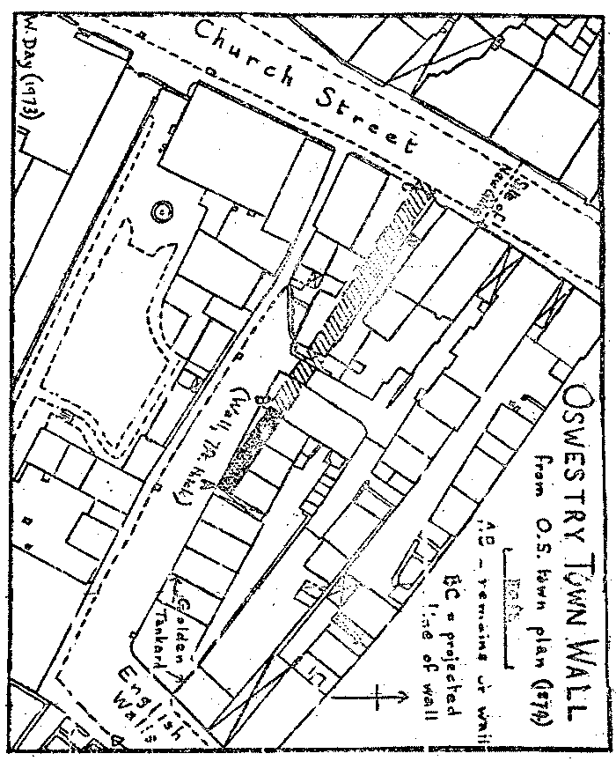

The original sketch map, drawn by the late Mr. W. Day, to illustrate the discovery in June 1973 of a section of Oswestry town wall beneath Nos. 2-4 Welsh Walls.

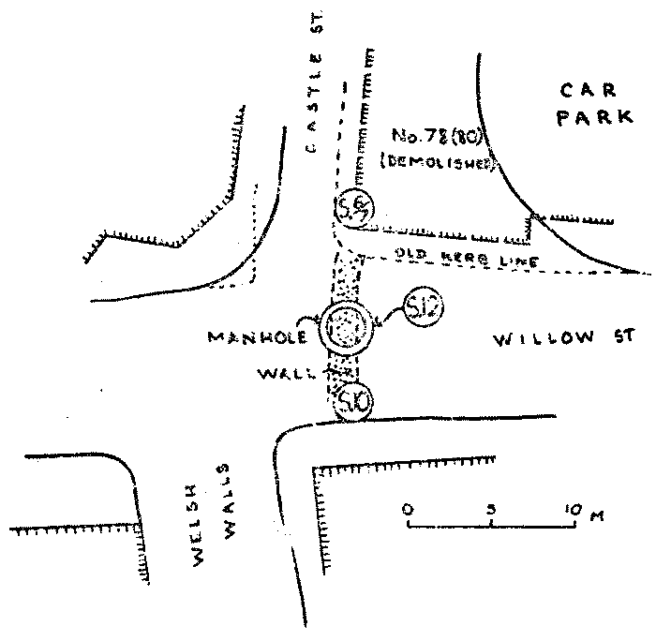

Map to show the sightings (‘S’) of the town wall at the junction of Castle and Willow Streets. Figures refer to relevant paragraphs in text.

something like 8ft, "and goodness knows (he added) how much further down it went". The old wall consisted of huge blocks of stone, some of it Sweeney rock, varying in weight from three to five hundredweight, and mortar, and was as solid as a rock.
It may be mentioned that a few feet away from the wall, the builders came across a flight of seven steps leading from the ground floor to a kind of subterranean passage, leading towards Willow Street, further progress being blocked by a door. The passage was not explored, and the door has been covered up with brick walling. The work of reconstruction is well advanced, and up to the present, apparently, it has not occurred to anyone as fitting to replace one of the stones (suitably inscribed, to mark the position of the old wall" (*78). This description obviously relates to No. 6 above. Does the reference to replacing
a stone signify that the exposed section of wall was completely removed by workmen? Or only in part? If the latter it goes some way towards confirming the comments made by Mr. J.J. Williams, resident engineer for the Willow Street sewerage scheme, who, in December 1980, stated that the section of the wall exposed in his trench "is not in a straight line or of even thickness" as it ran north into Castle Street (see No.12 below). The dimensions of the wall as given above appear to relate to a complete cross-section, and would indicate a very slender structure. Such measurements conflict with the generally accepted estimates obtained from the Welsh Walls sighting in 1973 (see No. 9 below).
- “…. during excavations for building purposes in a garden adjoining Welsh Walls, some years ago, a portion composed of huge blocks of sandstone, with mortar which had become as hard as the stone, about six foot thick and four feet in height, was unearthed ..." (*79). This may be tentatively attributed to the 1920s, but on which side of Welsh Walls was the discovery made? Possibly the east side, where outhouses, small stables etc. belonging to houses in Willow Street abut onto Welsh Walls and have seen frequent conversions to almost every possible alternative use. A thorough exploration of the rear garden of No. 55 Willow Street (see excavation report in Part IV) proved negative, and suggests that the wall at that point must underlie the road or pavement in Welsh Walls. This particular sighting, therefore, was probably made in the garden of one of Nos. 59- 65 Willow Street.
- “No sign of the Town Walls appears above ground today, but in June 1973 part of them was uncovered in excavations made for the new premises of Messrs. Mumford near the ‘Golden Tankard’ public house. The opportunity was taken of plotting on the 1:500 O.S. map of 1874 what was left standing of the wall. All was below the ground level of the previous building. The accompanying plan shows the line of the wall as found, and what the position of the wall would have been if it had continued on the same line towards the New Gate" (*80). The actual plan which accompanied the late Mr. W. Day’s record of this discovery is given on page 34. The width of the wall as communicated by Mr. Day, was ‘about seven feet’. No larger scale drawings were made.
- Communication, dated 15 March 1981, by Mr, J. Pryce-Jones to the secretary of the B.C.A.G.: "Two or three years ago I was walking up Willow Street, and, at the junction of Willow Street with Welsh Walls, there was the inevitable road work. In this case, I think the hole was for gas. I looked into the hole and, at the bottom, I saw a section of the wall, quite thick, and large pieces of stone" (*81). This sighting was near the kerb face outside No. 65 (corner house) Willow Street, and would appear to have been in direct line with the November 1980 exposure (see No. 12 below) on the opposite side of the road.
- Communicated 31 October 1980 by Mr. Ewart Francis to the secretary of the B.C.A.G. that "... the G.P.O. had unearthed large boulders on the Arundel Road/Welsh Walls junction, on the Arundel Road side. It was difficult to decide what these were as the trench was not

big enough, but they were certainly large enough to have been used in the construction of the wall" (*82). This trench was excavated in close juxtaposition to the suspected line of the wall. From the limited amount of information at our disposal, these large boulders may possibly represent ‘tumble’ from the wall.
- On 30 October 1980 the contractors for the new sewer in Willow Street broke through the foundations of the town wall at the junction of Willow Street and Castle Street. A manhole was being constructed a foot inside the white line running down the centre of Castle Street (see map on page 31). Although the B.C.A.G. were holding a watching brief, in the short space of thirty minutes the stone and mortar had been dug out and steel and timber shuttering erected along the sides of the trench prior to the pouring of concrete. It was noticed, however, that the upper layers of the stone work had already been disturbed by the laying of G.P.O. and electrical cables. The wall was visible, partial cross-section only, in the north side of the trench, and according to the resident engineer, visibly narrows and changes alignment by about 30º (see No. 7 above). The wall could not be seen in section in the south face of the trench, and had either been removed with the laying of the original Victorian sewer which lies alongside the new one, or the manhole possibly marks the point where the wall terminated at the Willow Gate (*83).
Overall, the above reports make frustrating reading, and shed little light on the problem of recovering the line and dimensions of Oswestry’s medieval wall. Indeed, by their very inadequacy, the records of casual sightings perhaps complicate rather than elucidate matters. This section of the report, therefore, is best terminated with a plea to owners and developers of sites along the conjectured line of the wall, that if actual physical traces are discovered, please allow members of the B.C.A.G. sufficient time to make an adequate record of the find!

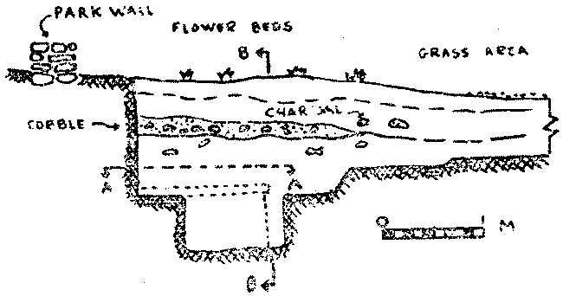
West end of trench, Cae Glas Park, November 1979

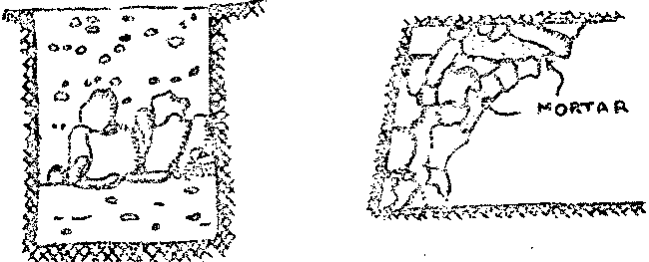
Plan on A – A Elevation B - B

IV. EXCAVATION REPORTS
Between October 1979 and September 1980, as opportunity offered, members of the B.C.A.G. cut six exploratory trenches at intervals along conjectural line of Oswestry town wall in Cae Glas Park and Welsh Walls. That they were able to adhere generally to the excavation strategy already outlined was due in no small measure to the generous co-operation and active encouragement on the part of Oswestry Borough Council, especially Mr. W.J. Philips, Chief Technical Officer, and Mr. and Mrs G. Jones, of Knockin, owners of the then ‘Walford Café’, now the ‘Walford Pine Shop’, Willow Street. The early excavations were carried out under the direction of Mike Edwards, Manchester University, whose reports, already circulated in the B.C.A.G. ‘Newsletter’, are collated below (*84). Plans and drawings are based on the work of Mr. George Holmes, B.C.A.G. honorary surveyor.
(A)
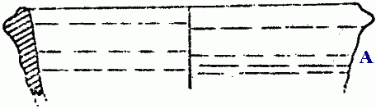
A. Flanged dish, brown fabric, done on wheel, with large inclusions, highly fired. Late medieval - 16th century.
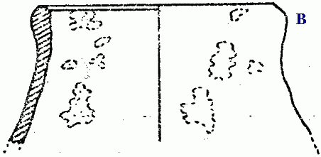
(B)

Half-scale

B. Necked beaker or jar, splash glaze inside and out, gritty fabric, .not highly fired. 15th century.
(C)
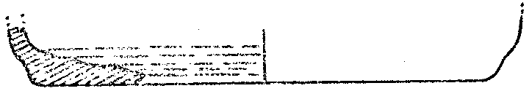
C. Midland purple, highly fired, stone, shallow dish, wheel made, 17th century.
(D)
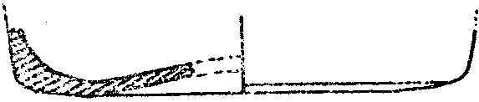
D. Light red coarse ware, grey core, oxydising atmosphere, wheel made, 17th century.

CAE GLAS EXCAVATION - POTTERY
(E)
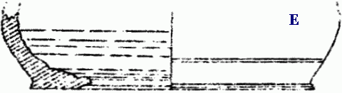

E. Midland purple, highly fired stone ware, shallow dish, wheel made. 16th century.
(F)
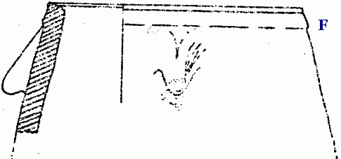
F. Midland purple, lug-handled cooking pot, splash lead glaze, very highly fired. Early 16th century.
(G)
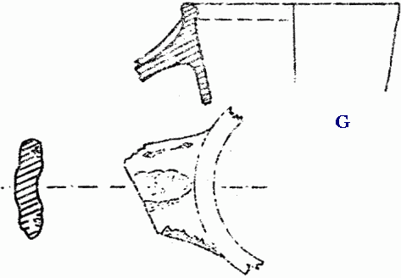
Half-scale
G. Slashed strap handle, coarse ware, splash green lead glaze. Late 14th - early 15th century.

CAE GLAS EXCAVATION - POTTERY

CAE GLAS PARK I
On 26 - 27 October and 3 - 4 November 1979 excavations were carried out near the tennis courts in Cae Glas Park (SJ 28872962), on the suspected line of Oswestry town wall between the New Gate and Willow Gate.
East of, and immediately adjacent to, an existing park wall a trench (8.5m x 1.5m wide) was cut across a lawned area and flower beds. The first weekend was spent removing earth and rubble that had obviously been brought into the park on various occasions for landscaping. Amongst this overburden, and therefore irrelevant for dating purposes, was found a silver coin of Edward I (1272-1307), which, from its thin profile and poor surface condition, was adjudged to be a contemporary forgery. By the end of the first week a cobbled area had been reached, extending a quarter of the way along the line of the trench.
The following week-end, after recording, this cobbled surface was stripped away to reveal a destruction layer containing a great quantity of stone, bone and pottery of a medieval date. In the north-western corner of the trench, hard up against the present park wall, were found a number of large, dressed stones that must have tumbled from a wall of considerable size. (A fragment of town wall discovered in 1973 was 2.5m wide). Associated with these stones was a small area of worn paving slabs lying on the natural boulder clay. A pit, possibly oval-shaped was only partially excavated, but it, too, had a large dressed stone in the bottom, implying that it was open and contemporary with the tumble from the wall. The features of this particular trench suggested that the medieval wall possibly underlies the park wall and adjacent tarmaced surface.
Some 514 pieces of bone, teeth and tusk were recovered from the trench, distributed stratigraphically as follows: landscaping material - layer 1, 54 bones, 14 -teeth; layer 2, 14 bones, 45 teeth; layer 3, 10 bones; layer 4 (destruction layer, much disturbed), 308 bones; layer 5, (medieval, undisturbed), 69 bones. The material was largely fragmentary, and was not subject to detailed pathological examination. Less than a quarter of the fragments could be positively identified as emanating from cow, ?bull, sheep, ?goat, pig, dog and birds - duck, goose and domestic fowl. The unidentifiable fragments were divided where possible into ‘large’ (Bos, Equus and Ovicaprid) and ‘small’ (Canis) mammals, and this demonstrated the predominance of large animals. Possible butchering marks were visible on several fragments.
The trench also threw up an hetrogenous collection of pottery. In layers 2 and 3 particularly the pottery ranged over a wide spectrum, late17th to 20th century. Material included china; porcelain; cream-ware; stoneware, glazed and unglazed; Staffordshire ware; mottled and trailed slip ware (brown/yellow); red ware; Buckley ware and Buckley type wares; black glazed ware; tin glazed ware; mottled ware, and glazed drain-pipe. Forms included sherds from bowls, jugs, tea pots, plates, cups, dishes, and large containers. Two medieval fragments were also trowelled up from these layers, with grey cores, buff exterior and green lead splashed glaze.
Layer 4 threw up four lead splashed glazed sherds and three Midland purple stoneware pieces:

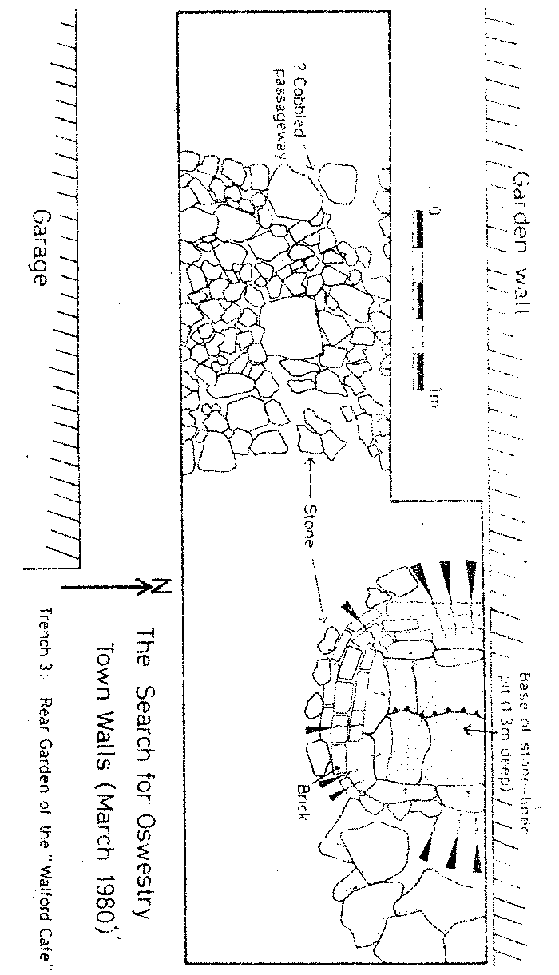
- lead splashed, light green glaze, grey core, orange outer surface.
- as above, but brown/green glaze
- slightly out-turned baluster jar rim and body sherd, dark brown splashed lead glaze, rough fabric, buff outer surface.
- thick buff sherd, grey core, quartz inclusions, lead splashed glaze, greeny/brown.
- Midland purple stoneware, basal sherd with red fabric, purple in tint.
- two Midland purple rims, flat, out turned, possible manganese/ iron glaze.
From amongst the stone debris at the bottom of the trench, layer 5 produced late medieval sherds, the fabric of which appeared to be local as did the inclusions:
- two stoneware bowl rims and body sherds, flanged rim, very hard fabric.
- two Midland purple stoneware basal sherds, unglazed.
- grey/buff fabric sherd, green splashed lead glaze.
- two slashed handles, thumbed rib groove down centre, pinky/orange fabric, sandy with green lead splashed glaze.
- slightly glazed red surface, grey core, wheel-made sherd, calcite inclusions.
- dark-green/brown glazed sherd.

CAE GLAS PARK II
Somewhere north-west of this first trench the town wall must make an almost right-angled bend to run on to the Willow Gate at the junction of Castle Street, Welsh Walls, and Willow Street. During the week-end 29 - 30 March 1980 three further trenches were cut in an effort to trace this new alignment. Two trenches were again located in Cae Glas Park, in the nursery gardens near the park superintendent’s house (SJ 28822969). Here, earlier in the week, workmen had uncovered the corner of a brick building. This structure, some four courses high and three bricks width thick, rested on the natural boulder clay and is absent from modern plans of the park. Local residents suggested that this brickwork comprised the remains of a Victorian open-air swimming pool owned by the tenants of two stone cottages that once stood in the grounds of Cae Glas mansion. The second trench did indeed reveal the existence of a brick-lined drainage channel, again resting on the natural clay, which may have been used to convey water to or from the swimming pool.
No trace of the town wall was found in either trench! Some fifty yards south-east of this site, along the eastern edge of the hard tennis court, is a brick wall which has a gap of just over a metre. A trench (3m x 1m) in this gateway may possibly cut the line of the wall.

WELSH WALLS
The third trench was located outside the park, in the cobbled entry to the rear garden of the ‘Walford Café’ (now the ‘Walford Pine Shop’), Willow Street, which backed onto Welsh Walls (see comments on excavation strategy, page 25, and reported sightings, page 32). Within an area limited by the close juxtaposition of a garden wall and garage, a trench 1.2m x 5.5m was opened up (see page 38). It lay within 1m of the present footpath in Welsh Walls (SJ 28832975).

At the western end of the trench, immediately below the surface cobbles, was a 10cm band of reddish, gritty clay, which in turn covered a layer of large stones and cobbles almost 2m wide, unmortared and resting on the natural clay, and occupying the width of the trench. No pottery was associated with this find, which, clearly not the footings of the town wall, has been interpreted as a crudely cobbled passageway.
At the eastern end of the trench a semi-circular line of hand-made bricks was traced down to its base, revealing a funnel-shaped structure lined with red clay, which led into a stone-lined and -bottomed pit, 75 cms below the level of the ‘cobbled way’ and full of ash and burnt debris, (it has been suggested elsewhere (page 17) that this ash, charcoal and other debris may be associated with one of the great fires that swept Oswestry in the sixteenth century).
The massive stone blocks, which showed more of the expected characteristics of a town wall, were traced down, but were discovered to be the end of a building, constructed from large stones and resting on the natural boulder clay. This is the first medieval building to come to light in Oswestry, and the pit described above appears to belong to a second phase of construction. Associated with this structure were a small number of pottery sherds and a little bone. The pottery has been identified as late medieval (l5th century) dark-green/brown lead glazed ware. The sherds, which are of coarse ware, seem to relate to wheel-made vessels, one possibly from a long-necked jug.
The failure to locate the course of the town wall in this trench suggests that its line is to be found running much closer to, and probably under, the footpath and road in Welsh Walls, There was still some scope in the garden of the ‘Walford Pine Shop’ for further exploration. This duly took place, under the supervision of Mr. Max Glaskin on 26/27 July and 20 September 1980, but with negative results, apart from giving everyone involved some good practice in excavation techniques!

APPENDIX ‘A’.

The form of a Murage Grant
Quoted in Oswald’s Well Magazine (September, 1848), I, pp. 178-9; I. Watkin, Oswestry &c., pp. 109-110; W. Cathrall, History of Oswestry &c., pp. 28-30.

Of the murage of Oswaldestre.
The king to the bailiffs and burgesses and other good men of Oswaldestre, greetings. Know that we have granted to aid in the enclosing of our town of Oswaldestre, that from the feast of St. Thomas the Apostle in the twelfth year of our reign (21 December 1283) to the end of twenty years thence ensuing, you may take in the same town, for the repair of the walls of the said town
From every horseload of saleable corn, ½d.
From every horse, mare, ox and cow sold, ½d.
From every fresh, salted or tanned hide of horse, mare, ox or cow, ¼d.
From every cart bringing salted flesh to sell, 2d.
From five porkers sold, ½d.
From a fresh salmon sold, ½d.
From ten sheep, goats or pigs sold, 1d.
From ten woollen fleeces, 1d.
From a hundred sheep, goat, stag, hind and doe skins, 1d.
From a hundred lamb, kid, hare, rabbit, fox, cat and squirrel skins, ½d.
From every cart of saleable salt, 1d.
From every horse-load of salt sold weekly, ¼d.
From every horse-load of cloth for sale, 1d.
From every entire cloth for sale in the town of Gloucester, 1d,
From every silk cloth brocaded and diapered with gold, 1d.
From every silk cloth without gold or chef de cendal, ½d.
From every cask of wine for sale, 2d.
From every horse-load of honey for sale, 1d.
From every cask of honey for sale, 4d.
From every sack of wool for sale, 4d.
From every bale of cloth for sale brought in by cart, 4d.
From every horse-load of cloth and sundry other small things coming to the same town to be sold, ½d.
From every cart-load of iron for sale, 1d.
From every horse-load of iron for sale, ½d.
From every wagon-load of lead for sale, 2d.
From tallow and lard for sale, ¼d.
From every hundred of alum and copperas for sale, ¼d.
From 2,000 onions, ¼d.
From every thousand of herring for sale, ½d.
From every hundred of boards for sale, ½d.
From every mill sold, 1d.
From every thousand of laths sold, 1d.
From every new cart sold, ½d. .
From every hundred of faggots
From every quarter of salt, ¼d.
From every dozen horse-loads of coal sold, ½d.
From every thousand of miscellaneous nails for sale, except cart nails, ¼d.
From a thousand of cart nails for sale, ½d.
From every hundred horse-shoes and cart-clouts for sale, ½d.
From every pack of sundry merchandise of the value of two shillings coming into the aforesaid town for sale, ¼d.
From every brewing cauldron sold, 1d.
From every quarter of oatmeal for sale, ½d.
And we therefore command that you take the said custom to the end of the term aforesaid, but once the said term of twenty years is complete the said custom shall cease and shall be completely abolished. In witness &c, at Shrewsbury ... ... (17 December 1283).

NOTES
- The remains of other earth and timber castles are to be found at Whittington, Brogyntyn, West Felton, Hisland, and ‘Oaklands’, Chirk Bank.
- Victoria County History of Shropshire, I, pp. 316, 321-2.
- It is most unlikely that a saint’s name is involved, in the derivation of Oswestry (M. Gelling, Signposts to the Past, pp. 186-7; W.F.N. Nicolaisen et. al., The Names of Towns and Cities in Britain, pp. 57-8, 146-7).
- 4. T. Jones (ed.), ‘Cronicon de Wallia’ , Bulletin Board of Celtic Studies, XII, pp. 27-44; T. Jones (ed.), Brut y Tywysogion Peniarth MS, 20 Version), pp 57, 63, 93, 103; T. Jones (ed.), Brenhinedd y Saeson, pp. 155, 167, 217, 229; J.G. Edwards (ed.), Calendar of Ancient Correspondence concerning Wales, pp. 26, 65, 80-83, 111, 154.
- R.W. Eyton, Antiquities of Shropshire, VII, p. 262; Cal. Inq. Post Mortem, II, pp. 283, 306, 337; Cal. Close Rolls 1272-6, pp. 513-5; M. Clough (ed.), Two Estate Surveys of the FitzAlan Earls of Arundel (Sussex Rec. Soc.), LXVII, pp. 74, 76-7; U. Rees (ed.), Cartulary of Shrewsbury Abbey, II, pp. 252-3.
- The Latin or French Blancmonasterium, Album Monasterium, Album Castrum etc. (in Welsh Y Fynachlog Wen) were the original names for Oswestry. Oswaldestre does not occur in any authentic record until 1272, although its Welsh equivalent, Croes Oswallt, is found in 1254. Possibly because of confusion with Album Monasterium or Whitchurch in north Shropshire, the name Oswestry is increasingly used after 1272.
- A.Ballard, British Borough Charters, 1042-1216,pp. 29, 81; Eyton, Antiquities, X, p. 324.
- Cal. Close Rolls 1227-31, pp. 82, 121; ibid., 1231-4, p. 226. The market privilege was withdrawn for a short time, then re-instated.
- A. Ballard and J. Tait, Borough Charters 1216-1307, pp. 159, 240, 296.
- C.T. Martin (ed.), Registrum Epistolarum Johannis Peckham &c. (Rolls Series), II, pp. 445-8.
- Cal. Inq. Post Mortem, I, pp. 216, 379-80$ J.Y.W, Lloyd, History of Powys Fadog &c., VI, pp. 336-7; Cal. Close Rolls 1272-6, pp. 507-8; P.R.O. (Pipe Rolls) E 372/121, account of the sheriff of Shropshire for 1276-7.
- Cal. Pat. Rolls 1247-1258, p. 609; D.C. Robert’s, Some Aspects of the History of the Lordship of Oswestry to 1300 (unpublished University of Wales M.A. thesis, 1939), pp. 54-5.
- Cal. Pat. Rolls 1272-81, p.187; J.E. Morris, The Welsh Wars of Edward I, pp. 115, 120, 145-6; F. Palgrave (ed.), Parliamentary Writs &c. (Rec. Comm.), I, pp. 5, 193.
- Cal. Pat. Rolls 1272-81, pp. 223, 247; D.C. Roberts, op. cit., pp. 60-61.
- J.C. Davies (ed.), The Welsh Assize Roll 1277-84, pp.206-9.
- Cal. Chanc. Rolls, Various, p. 229; J.E. Morris, Welsh Wars &c., p. 172. Replaced 8 August by Edward Mortimer (Cal. Pat. Rolls 1281-92, p, 32.)
- J.C. Davies, Welsh Assize Roll 1277-84, pp. 206-9, 351-3.
- Cal. Pat. Rolls 1281-92, pp. 57, 108; D.C. Roberts, op. cit., p. 61.
- Quoted in Oswald’s Well Magazine (September, 1848), I, pp.178-9; I. Watkin, Oswestry &c., pp. 109-110; W. Cathrall, History of Oswestry &c., pp. 28-30.

- I. Watkin, Oswestry &c., p. 306. Tolls were finally extinguished by purchase, for the sum of £800, from the earl of Powys by Oswestry Corporation in September, 1833. For the tolls leviable under the 1673 Charter see A. Roberts, ‘The Four Gateways of Oswestry’, Trans. Shrop. Arch. Soc. (1884-5), VIII, pp. 1-17.
- W. Price, The History of Oswestry &c., p. 83, reprinted in I. Watkin, Oswestry &c., p. 108 cf. D.C. Roberts, op. cit., Map 5.
- e.g. F. Noble, Oswestry : Medieval Borough Features (leaflet,1966); R.A. Griffiths (ed.), Medieval Boroughs of Wales, p. 218 (inaccurately drawn); maps in possession of B.C.A.G. with supposed line of wall as supplied by Oswestry Borough Chief Technical Officer.
- Bodleian Lib. Leland’s MSS. Gen. Top. e.12, ff. 39-40; L.T. Smith (ed.), The Itinerary in Wales of John Leland &c., pp. 74-6.
- Leland’s marginal note: ‘Welsh - Avon Crois = Cros Brook’.
- Agreement, dated 16 September 1772, between the earl of Powys and Oswestry Corporation re demolition of remaining gates (S. Leighton, ‘Records of the Corporation of Oswestry’, T.S.A.S. (1882), V, p. 164.
- I. Watkin, Oswestry &c., pp. 109, 112; W. Cathrall, History of Oswestry &c., pp. 93-4.
- It has been variously stated that Beatrice Gate was called after either (a) Beatrice, wife of Hugh Cyfeiliog, earl of Chester (1162-81), (b) Beatrix, wife of Thomas, earl of Arundel, lord of Oswestry (1400-15) or (c) a non-existent Beatrice, queen of Henry IV (I. Watkin, Oswestry &c., p. 319; W. Cathrall, History of Oswestry &c., p.94). It takes, its name from the street, and in no way can the early forms Baderiche (1302), Bader (1393), Bet(e)rich(e) (1539, 1577, 1585, 1602), Bett(e)ridge (1550), Baderick, Baderish (1564), Betrige (1577), be twisted into Beatrice. .
- H.M. Colvin (ed.), History of the King’s Works, I, pp. 333-5; A.J. Taylor, The King’s Works in Wales 1277-1330, pp. 385-6, 468-9.
- W.J. Slack, The Lordship of Oswestry 1393-1607, p. 151; I. Watkin, Oswestry &c, p. 313; W. Cathrall, History of Oswestry &c., p. 184.
- U. Rees, Cartulary of Shrewsbury Abbey, II, p. 253.
- A.H. Smith, English Place-name Elements, I, p. 118; I. Watkin, Oswestry &c., pp. 163, 268.
- Lands belonging to the Knights Hospitaller of St.. John and the abbeys of Haughmond and Shrewsbury, Tenants of the latter were permitted to use Oswestry market (U. Rees, Cartulary of Shrewsbury Abbey, II, pp. 282-3) and their lands in Scheldemer (within the liberties of the borough) had been appropriated by Richard FitzAlan I sometime before 1302 (ibid., I, p. xxxcf. M. Clough, Two Estate Surveys &c., p. 68; W.J. Slack, Lordship of Qswestry, p. 150).
- Significantly, in 1351 Bromfield and Yale was valued at £831 and Oswestry only at £233 (S.R.O. 552/1A/1). In 1366 the lordship of Chirk was worth £513 (N.L.W. Chirk Castle MSS., D.28).
- Cal. Charter Rolls 1341-1417, pp. 373-5; S. Leighton, ‘Records of the Corporation of Oswestry’, T.S.A.S. (1879), II, pp. 199-207; J.Y.W. Lloyd, History of Powys Fadog &c., VI, p. 319. For evidence of fraternities or gilds see N.L.W. Aston Hall MS. 947; Peniarth MS. 949.
- S. Leighton, ‘Records of Oswestry Corporation’, T.S.A.S. (1880), III, pp. 78-9.
- W. Cathrall, History of Oswestry &c., pp. 58, 77-82.
- Cal. Close Rolls 1268-72, pp. 507-9; Cal. Inq. Post Mortem, I, pp. 216, 279-80; M. Clough, Two Estate Surveys &c., pp. 65-7; W.J. Slack, Lordship of Oswestry, pp. 143-152; J.Y.W. Lloyd, History of Powys Fadog &c., VI, pp. 332-4.
- P.R.O. (Lay Subsidy Rolls) E 179/166/178 for 1542 cf. W.J. Slack, Lordship of Oswestry, pp. 49~56 (1602 Survey), pp. 126-141 (1577 Survey).
- For the following details of the borough in the latter half of the 14th century see W.J. Slack, Lordship of Oswestry, pp. 142-152; N.L.W. Aston Hall MS. 6918 (receiver’s account for 1362-3).
- L.T. Smith, Itinerary in Wales of John Leland, p. 75.
- See map ‘Town and Liberties, 1795’ in I. Watkin, Oswestry &c., pp. 12, 86 cf. W.J. Slack, Lordship of Oswestry, p. 135.
- N.L.W. Aston Hall MS. 1918.
- P.R.O. (Anc. Pet.) SC 8/251/5 cf. W. Rees, Calendar of Ancient Petitions Relating to Wales, p. 418.
- W.J. Slack, Lordship of Oswestry, pp. 46, 53.
- ibid., pp. 129-133.
- In modern terms Middle Street was that part of present-day Church Street extending from the Cross to New Gate. See also Shrewsbury Local Studies Library MS. 9025.
- In 1302 there were 13 burgages in Scheldemer extended as a distinct area in M. Clough, Two Estate Surveys &c., p. 68 cf. W.J. Slack, Lordship of Oswestry, p. 150 where the name Scheldemer seems to be falling into disuse in favour of Chirton.
- L.T. Smith, Itinerary in Wales of John Leland, p. 75.
- Cal. Close Rolls 1268-72, pp. 5-7-9.
- P.R.O. SC 6/967/23. Fragmentary account, undated, but from the tenure of Edmund Mortimer.
- The tenter frames were probably in the castle ditch. See 1602 Survey (W.J. Slack, Lordship of Oswestry, p. 51) where reference is made to "A certaine voide ground in the castle ditche where have been denters".
- J.E. Lloyd, Owen Glendower, p. 32; J.Y.W. Lloyd, History of Powys Fadog &c., VI, p. 309.
- B.L. Harl. MS. 1981, ff. 8-9 cf. J.Y.W. Lloyd, History of Powys Fadog, VI, p. 310.
- W.J. Slack, Lordship of Oswestry, pp. 44-56, especially pp. 45, 47-8.
- Tenseria = payment by non-burgesses for trading rights. For other allegations of misappropriation of murage monies see Oswestry: MS Copies of Records (Oswestry Public Library), p.108; W. Price, History of Oswestry &c., pp. 25-6; S. Leighton, ‘Records of the Corporation of Oswestry’, T.S.A.S. (1881), III, pp. 77-8.
- Mrs. Stackhouse Acton, Garrisons of Shropshire 1642-8, p. 65; I. Watkin, Oswestry &c., p. 289.
- For the various accounts of Oswestry in the Civil War see J.R. Phillips, Memoirs of the Civil War in Wales and the Marches 1642-49, I, pp. 222-6, II, pp. 173-88; J. Parry Jones,’Story of Oswestry Castle’, T.S.A.S. (1894), VI, ii, pp. 150-7; S. Acton, Garrisons of Shropshire &c, pp. 65-70; W, Blakeway, Account of the Woollen Industry and the Siege of Oswestry (S.L.S.Lib.); W. Cathrall, History of Oswestry &c., pp. 65-70; I. Watkin, Oswestry &c., pp. 289-92; R. Gough, History of Myddle &c., p. 179.
- I. Watkin, Oswestry &c., p. 111,
- ibid., p. 292.
- W. Cathrall, History of Oswestry &c., p. 82,
- J. Parry Jones, ‘Story of Oswestry Castle’, T.S.A.S. (1894), VI, ii, p.171.
- S.R.O. 1043/6.
- S.R.O. 1043/7.
- S.R.O. 1043/1. For other presentments to 1764 see I. Watkin, Oswestry &c., pp. 115, 167, 238, 320.
- I. Watkin, Oswestry &c., pp. 112-6.
- ibid., p. 115.
- ibid., pp. 115, 238.
- ibid., p. 115.
- ibid., pp. 147, 238-241, 293-4, 320.
- See nn 21, 22 above.
- I. Watkin, Oswestry &c., pp.111-112.
- ibid., p. 112,
- ibid., p. 128.
- ibid., p. 329.
- ibid., p. 279.
- Bygones (1888), p.179
- I. Watkin, Oswestry &c., p.167.
- Bygones (1907), pp. 76-7; letter to B.C.A.G. Secretary.
- I. Watkin, Oswestry &c., p. 111.
- W. Day, ‘Oswestry Town Walls’, T.S.A.S. (1973-4), LIX, iii, pp. 278-9.
- Letter to B.C,A.G. Secretary,
- Verbal communication to B.C.A.G. Secretary.
- Letters and maps supplied to B.C.A.G. Secretary.
- B.C.A.G. Newsletters, Nos. 7, 8, and 10; D.Pratt, ‘The Search for Oswestry Town Wall’, West Midlands Archaeology No. 23 (1980), pp. 106-8.

